VALUATION METHODOLOGIES:

***Valuation***:

* Managers need to be able to value operations, opportunities, and ownership claims.
* A public company could be valued by looking at the market value of equity.
* A firm with a long history of financial accounts, could benefit from the analysis of earnings, and cash flow projections.
* But the valuation of a small, privately held firm is difficult and uncertain.

***Misconceptions about valuation:***

Myth 1: A valuation is an objective search for “true” value

* Truth 1.1: All valuations are biased.
* Truth 1.2: The direction and magnitude of the bias in your valuation is directly proportional to who pays you and how much you are paid.

Myth 2: A good valuation provides a precise estimate of value

* Truth 2.1: There are no precise valuations
* Truth 2.2: The payoff to valuation is greatest when valuation is least precise.

Myth 3: The more quantitative a model, the better the valuation

* Truth 3.1: One’s understanding of a valuation model is inversely proportional to the number of inputs required for the model.
* Truth 3.2: Simpler valuation models do much better than complex ones.

**Value**: From an economic perspective, value is the present value of future free cash flows (FCF) expected to be produced by the company, discounted at the weighted average cost of capital (WACC) that reflects the risk of the cash flows.

**BOOK VALUE:**

It is important to understand that the value of equity in the accounting balance sheet is NOT what the shareholders can obtain if they sold the company and paid off all the debt.

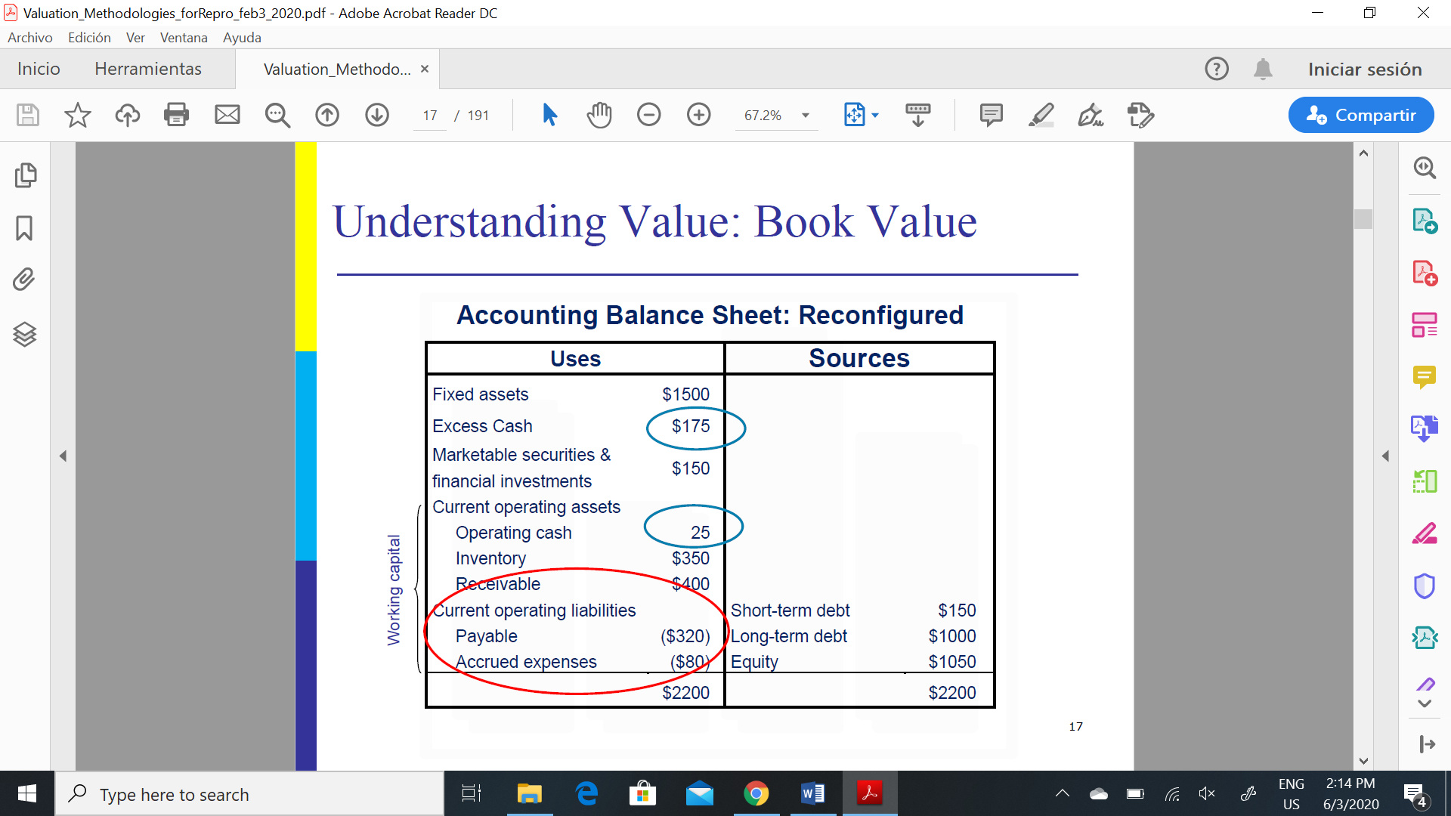

-The total capital (on which a return must be provided) raised by the company is $2200. Accounts payable and accrued expenses are not included as they are not interest-bearing liabilities.

-Working capital= current operating assets – current operating liabilities

**ECONOMIC VALUE:**

The main difference is that:

* Values in the accounting balance sheet represent what has been invested.
* Values in the economic balance sheet represent the current value of what has been invested.

*Goal* of companies is to ensure that the economic value **exceeds** the accounting value!!

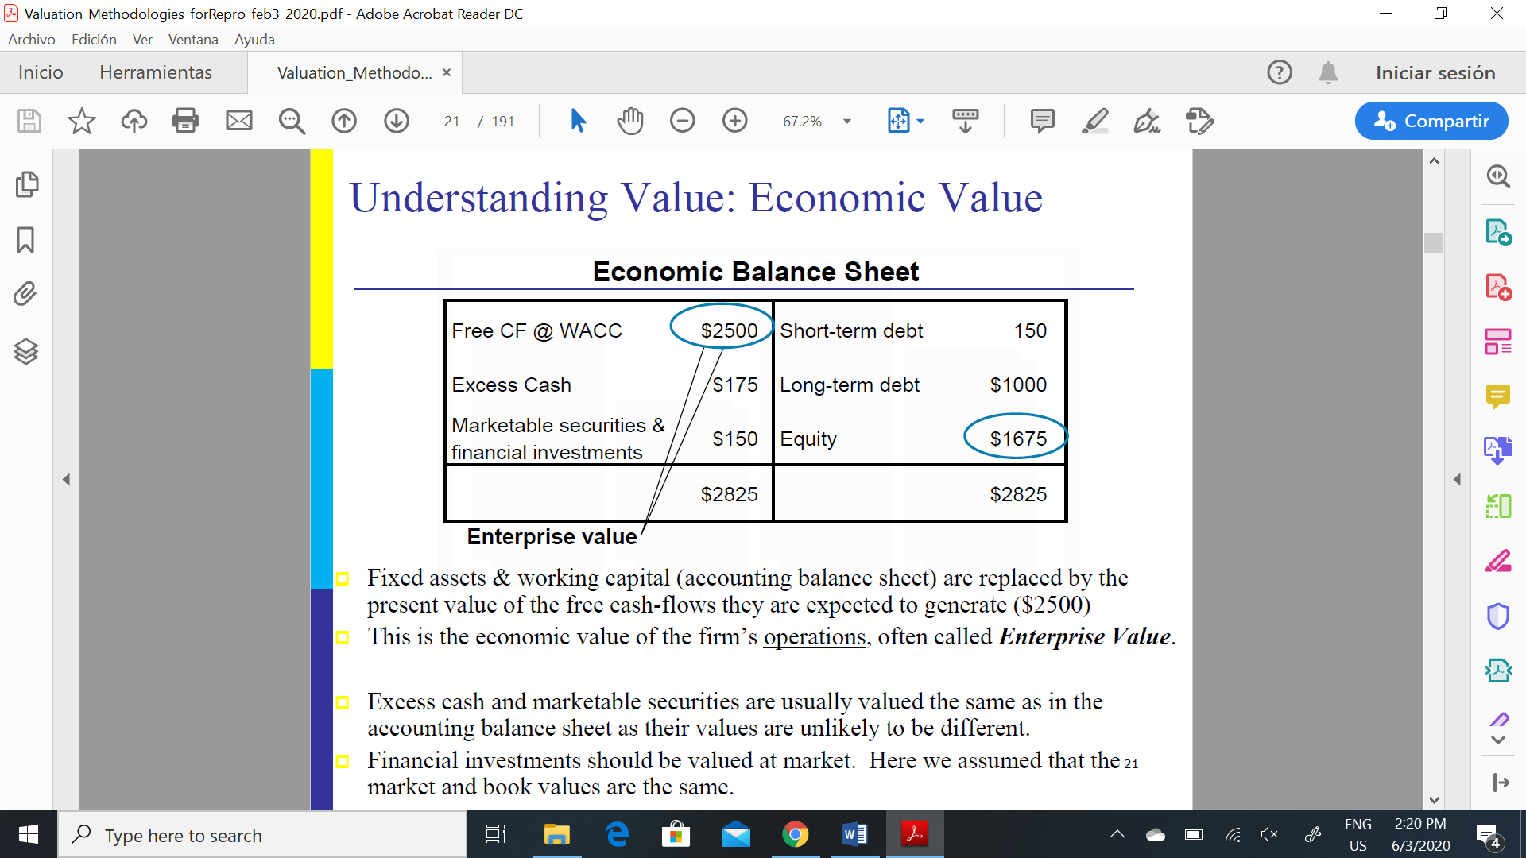

The total value of the company is:

* Enterprise Value + Excess cash + Marketable securities + Financial investments
* Value of equity= total value of the company – liabilities 🡪 market capitalization

If a company is publicly traded, it is easy to construct the right side of the balance sheet:

* Debt values, Value of items such as excess cash, marketable securities, and financial investments can be obtained from the accounting balance sheet
* Equity value can be calculated by multiplying the share price by the number of outstanding shares.
* The enterprise value can then be calculated as the residual.

VALUATION APPROACHES:

1. **Net asset approach:**

- focuses on the balance sheet and posits that the company is worth the sum of the value of its net assets.

- relevant when the company is experiencing financial difficulty and investors prefer valuing it as a portfolio of assets rather than a going-concern

- provide a floor to the value of a company since owners of the company will likely be reluctant to sell at less than NAV.

***LIMITATIONS***:

- accounting-based values are often very different from market values: depreciation can be arbitrary, stock values can be underestimated

- Other limitations have to do with the treatment of asset accounts (intangible assets) such as R&D costs, patents, and organization expenses

ADJUSTED BOOK VALUE: re-value tangible assets using their estimated market value and intangible assets reduced to 0 unless they have market value

LIQUIDATION VALUE: net cash which could be realized if the assets of the firm were disposed of in a “quick sale” and all liabilities of the firm were paid off. This value is not of importance to a buyer interested in the maintenance of the business as an on going concern, but could be used as a floor below which the seller would be unwilling to sell to the buyer

REPLACEMENT VALUE: current cost of reproducing the tangible assets of a business

1. **Multiples approach:** Valuation of a firm may also be done by capitalizing earnings. This

involves multiplying an earnings figure by a capitalization factor or P/E ratio. (infer from similar companies how much the company will be worth)

3 kinds of earnings:

-Historical earnings: history can be used to predict future

-Future earnings under **present** ownership: depend upon the polices and strategies of management; not good if owner will fire the manager

-Future earnings under **new** ownership: basis of the figures might be different for the past ones; new investments might be needed.

Most valuations use:

-Earnings after tax

-EBIT: measures the earning power and value of the basic business, without the effect of financing, this is particularly important if the financial structure will change.

Two categories:

-Trading multiples: If we consider that the investor’s primary return might result from

the sale of its stock in the future. (What will someone be willing to pay for my holdings? What prices are paid for stocks of similar records and histories?)

* * P/E ratios: most common, measures the relationship between a company’s current earnings per share and the price of a share of its stock (P/E ratio of 10x, an investor must pay ten times the company’s current earnings per share to acquire one share of its stock)
* * Others: Equity Value / Sales, Equity Value / EBITDA, Equity Value / EBIT, Firm Value / Net Income
* * Book value multiples: measure of the value of a firm based on the historical costs of its assets

-Transaction multiples: measured at the time of a transaction, to reflect the price paid for the

acquisition. Measure of how similar companies were valued by competitors and how big of a premium acquirers were willing to pay for the control of the acquired companies. *They tend to be higher than trading premiums due to the control premium.*

***DISADVANTAGES***:

Relative valuation is built on the assumption that markets are correct in the aggregate, but make mistakes on individual securities. To the degree that markets can be over or under valued in the aggregate, relative valuation will fail

1. **Discounted dividend approach:** values the stock of a company as an infinite stream of future dividends, discounted by the company’s cost of capital.

P= D1 / (k – g)

retention ratio, b, = 1-dividend payout ratio.

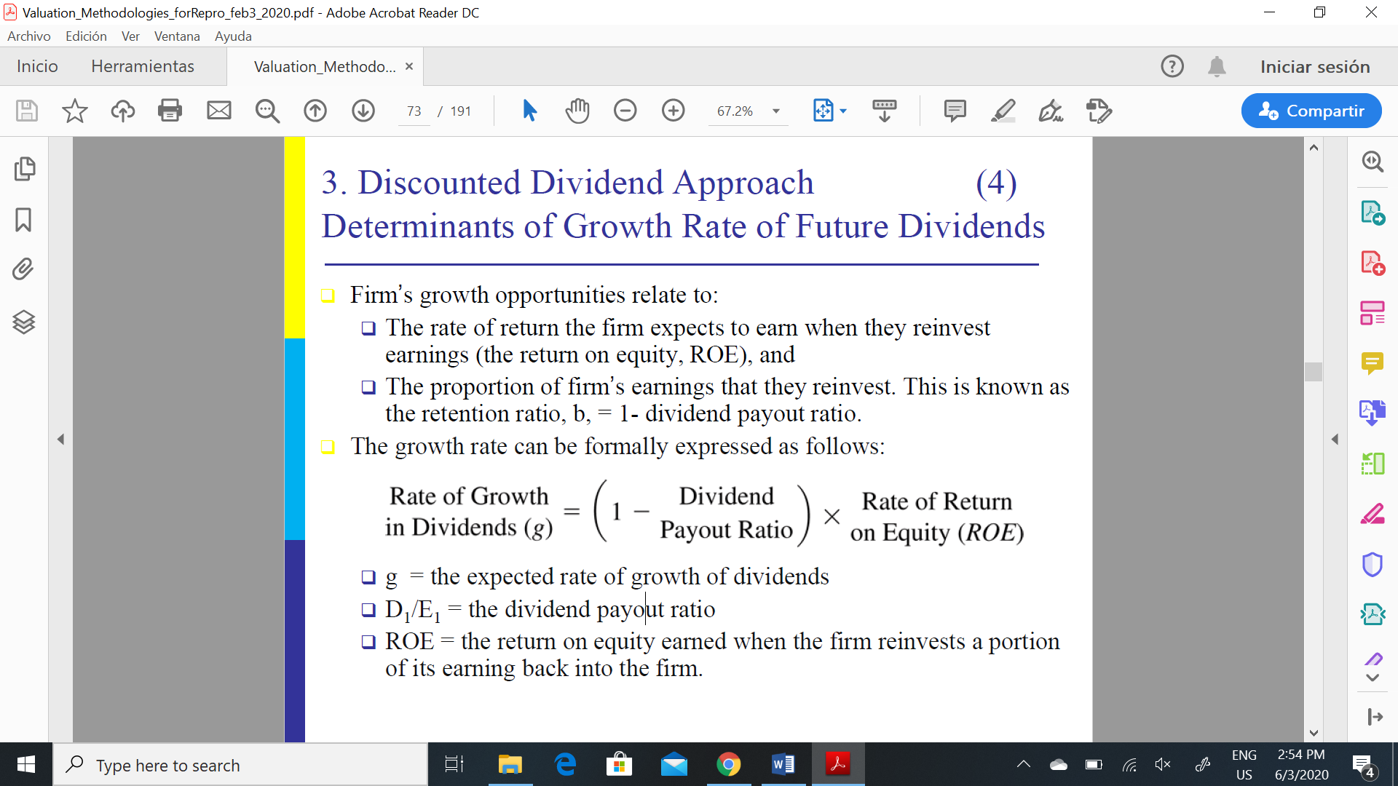

***Limitations***:

- extremely sensitive to the growth rate to infinity, which is difficult to estimate and can be somewhat arbitrary since theoretically a firm cannot have abnormal returns for ever.

- assumption that dividends will grow at a constant rate.

- cannot be used when a company pays no dividends or has an unstable dividend pattern

- cannot be used either if the firm’s cost of capital is less than the dividend growth rate (k<g)

- cost of equity (k) can be difficult to estimate

1. **Discounted cash flow model:** regards businesses as a series of risky cash flows stretching into the future. Discount the CF forecasts to present value at the opportunity cost of funds. Use this when firms don’t pay dividends or when dividends are hard to forecast

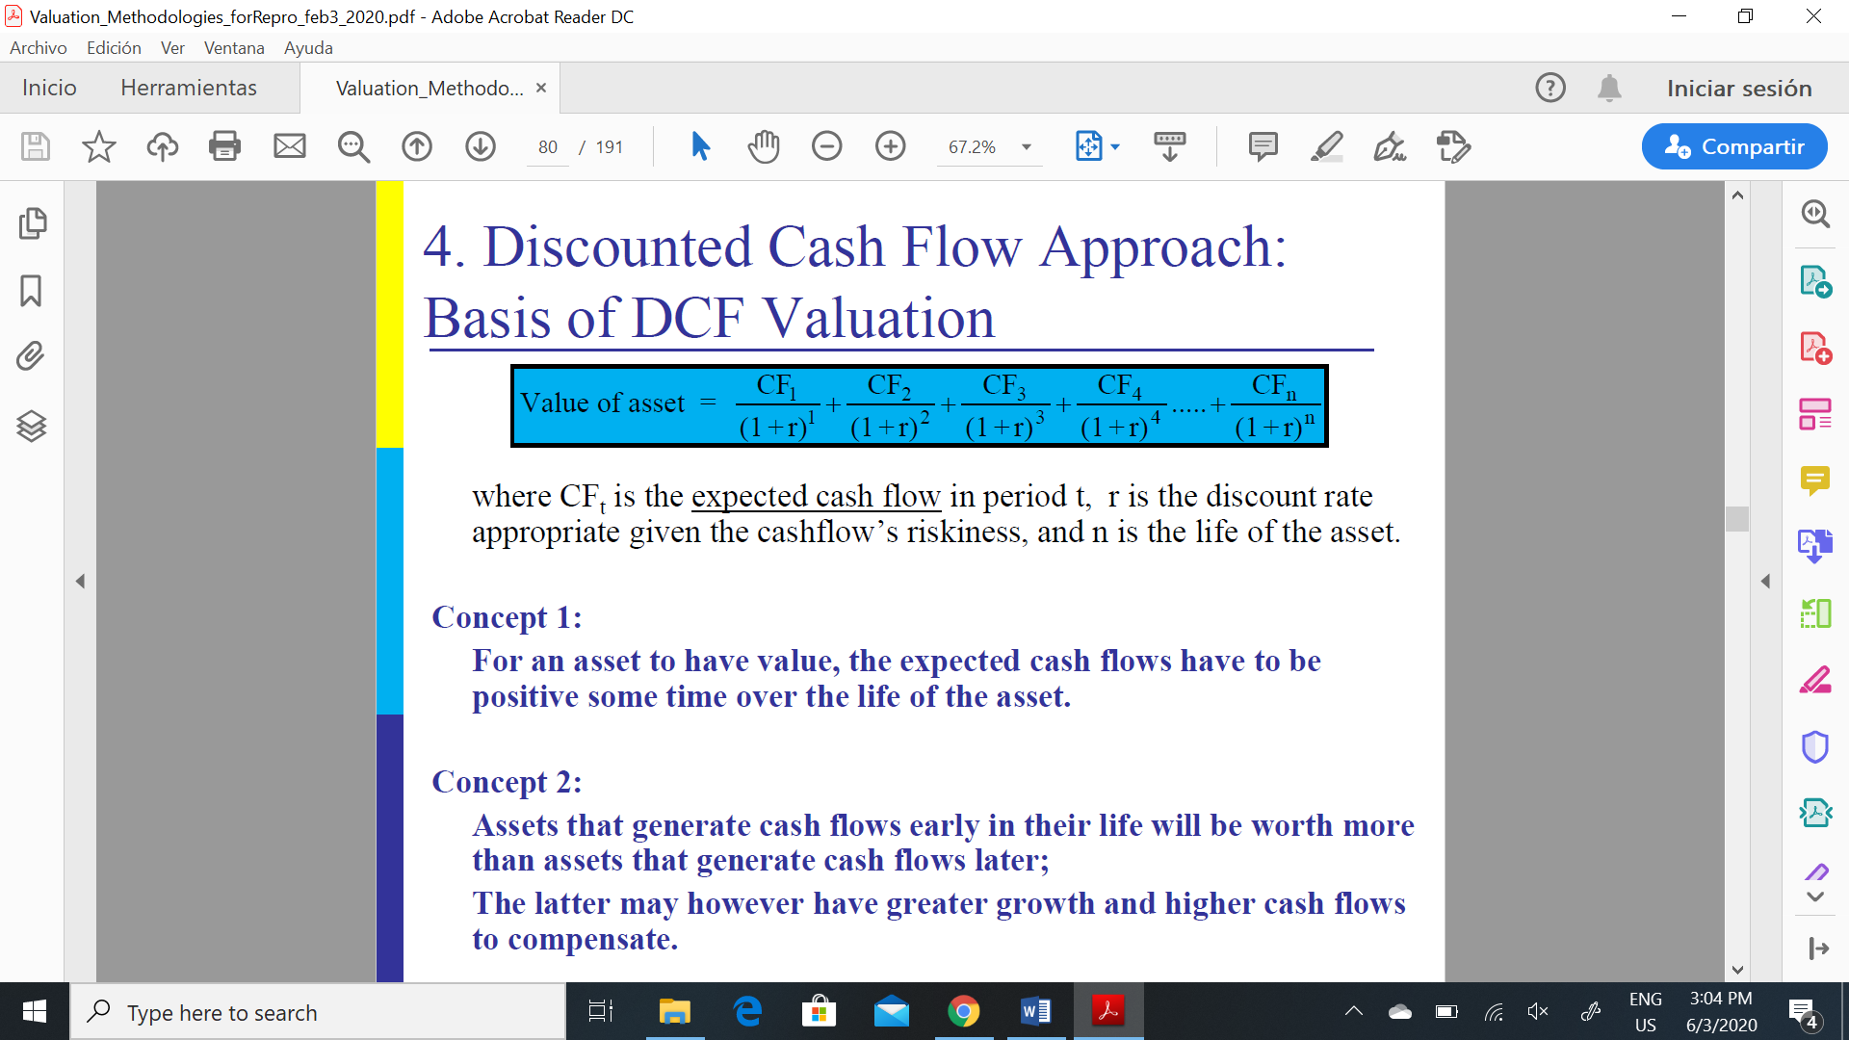

-Concept 1: For an asset to have value, the expected cash flows have to be positive some time over the life of the asset.

-Concept 2: Assets that generate cash flows early in their life will be worth more than assets that generate cash flows later

Opportunity costs of funds: return a company (or its owners) could expect to earn on an alternative investment entailing the same risk.

- time value—the return on a nominally risk-free investment.

- risk premium —the extra return you can expect commensurate with the risk you are willing to bear

Required rate of return: determined by: risk free rate, expected rate of inflation, risk premium

Firm valuation: value the entire business

-CF from assets **prior** any debt payments but **after** a firm has reinvested to create growth assets

-discount rate reflects the cost of raising both debt and equity financing in proportion of its use

Equity valuation: value just the equity claims in the business

-CF from assets **after** debt payments and after making reinvestments needed for future growth

-discount rate reflects the cost of raising equity financing

NOTE: To get from firm value to equity value, which of the following would you need to do? Subtract the value of any debt that was included in the cost of capital calculation. Doing so, will give you a value for the equity which is: equal to the value you would have got in an equity valuation

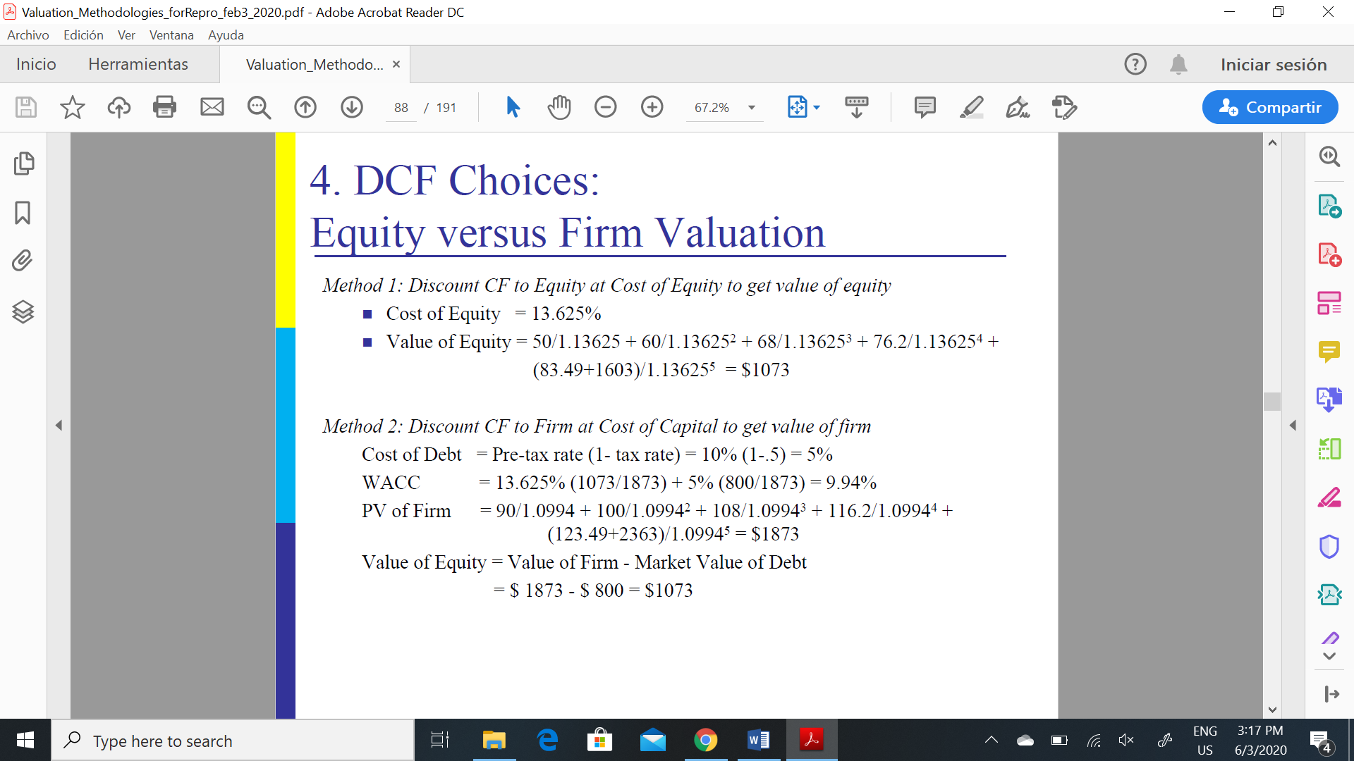

*Error 1: Discount CF to Equity at Cost of Capital to get equity value, Value of equity is overstated

* Error 2: Discount CF to Firm at Cost of Equity to get firm value, Value of Equity is understated

* Error 3: Discount CF to Firm at Cost of Equity, forget to subtract out debt, and get too high a value for equity

3 METHODS: (differ in 2 things: measure of CF and discount rate applied)

1. **FCF METHOD (FCF)**: value of the entire firm equals the present value of the firm’s free cash flows. Free Cash Flows for its *stock holders and debt holders*

Market value of firm= Market value of stocks + Market value of debt

Enterprise value= PV of future CF

Value of equity= EV of firm – MV of debt

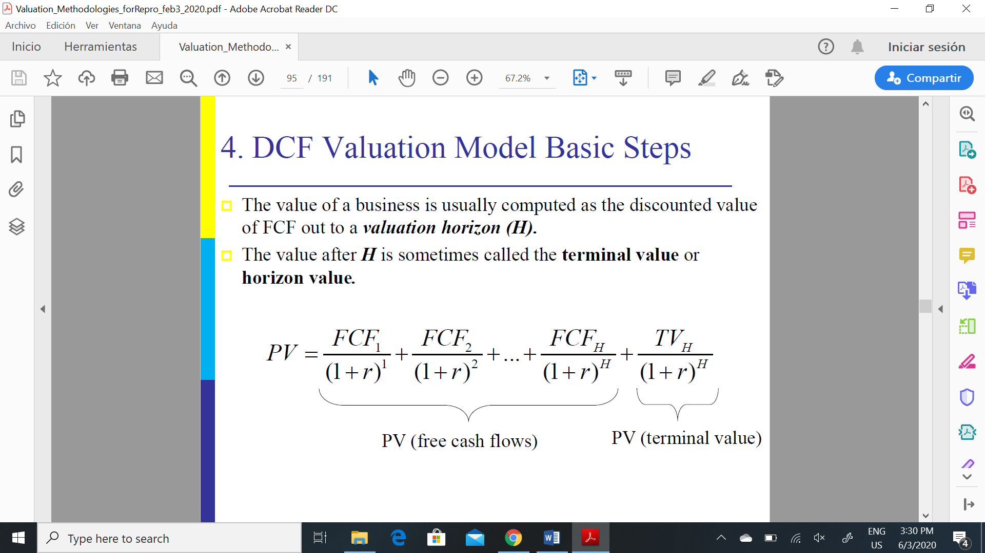

Free Cash Flow (FCF) =EBIT * (1 –tax rate) +Depreciation -Change in WC (Working Capital = Current Assets (w/o cash) –Current Liabilities) -Capital Expenditures

+depreciation: accounting expense but not a real cash outflow

*Changes in WC: transform inventories and payables into cash

- capital expenditures: pay for assets when they are bought

NOTE: if debt is 0 then FCFs are cash flows to investors if the firm were unlevered.

OTHER WAY:

Free Cash Flow = Net Income + Depreciation - Change in Working Capital - Capital Expenditures + Interest

Terminal value:

* Growing Perpetuity Cash Flow: CF expected to keep growing

* Stable Perpetuity Cash Flow: CF assumed to stay constant

* Multiple of Book Value: Multiply the terminal-year book value of the invested capital by an appropriate market value/book value ratio.

* Multiple of Earnings: Multiply the terminal-year profits value by an appropriate P/E ratio

* Liquidation: Assume a liquidation of the assets in the last year of the planning horizon.

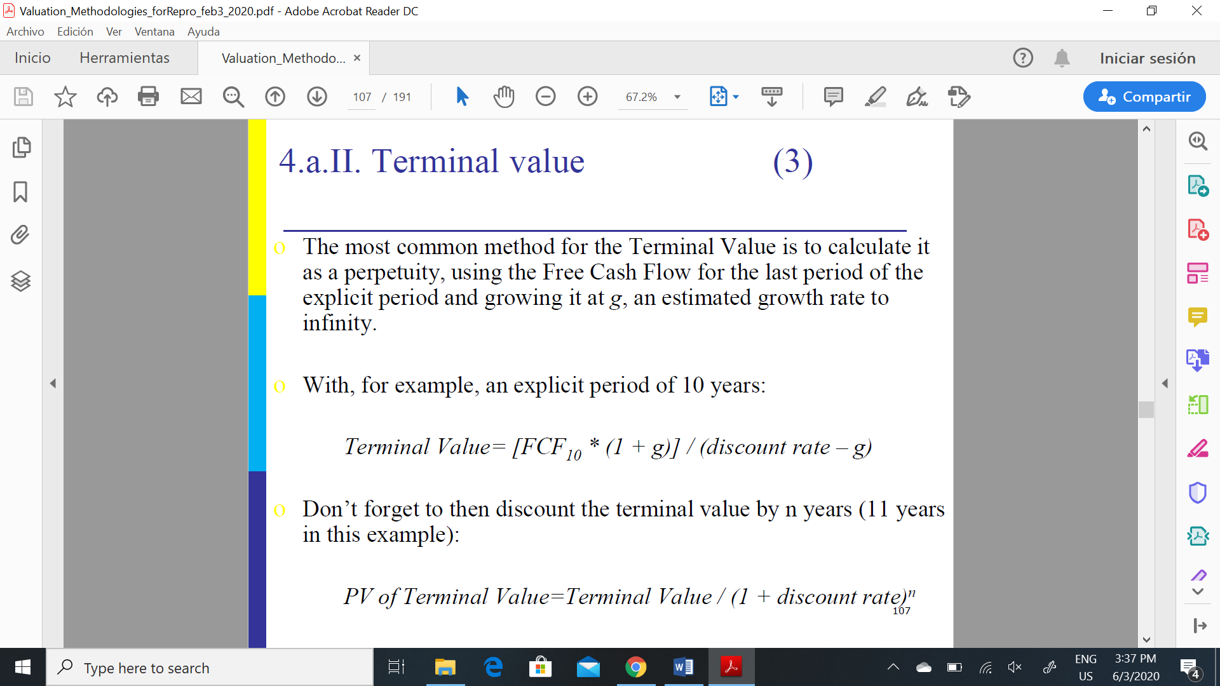

r> g

“constant” growth rate is called a stable growth rate and cannot be higher than the growth rate of the economy in which the firm operates

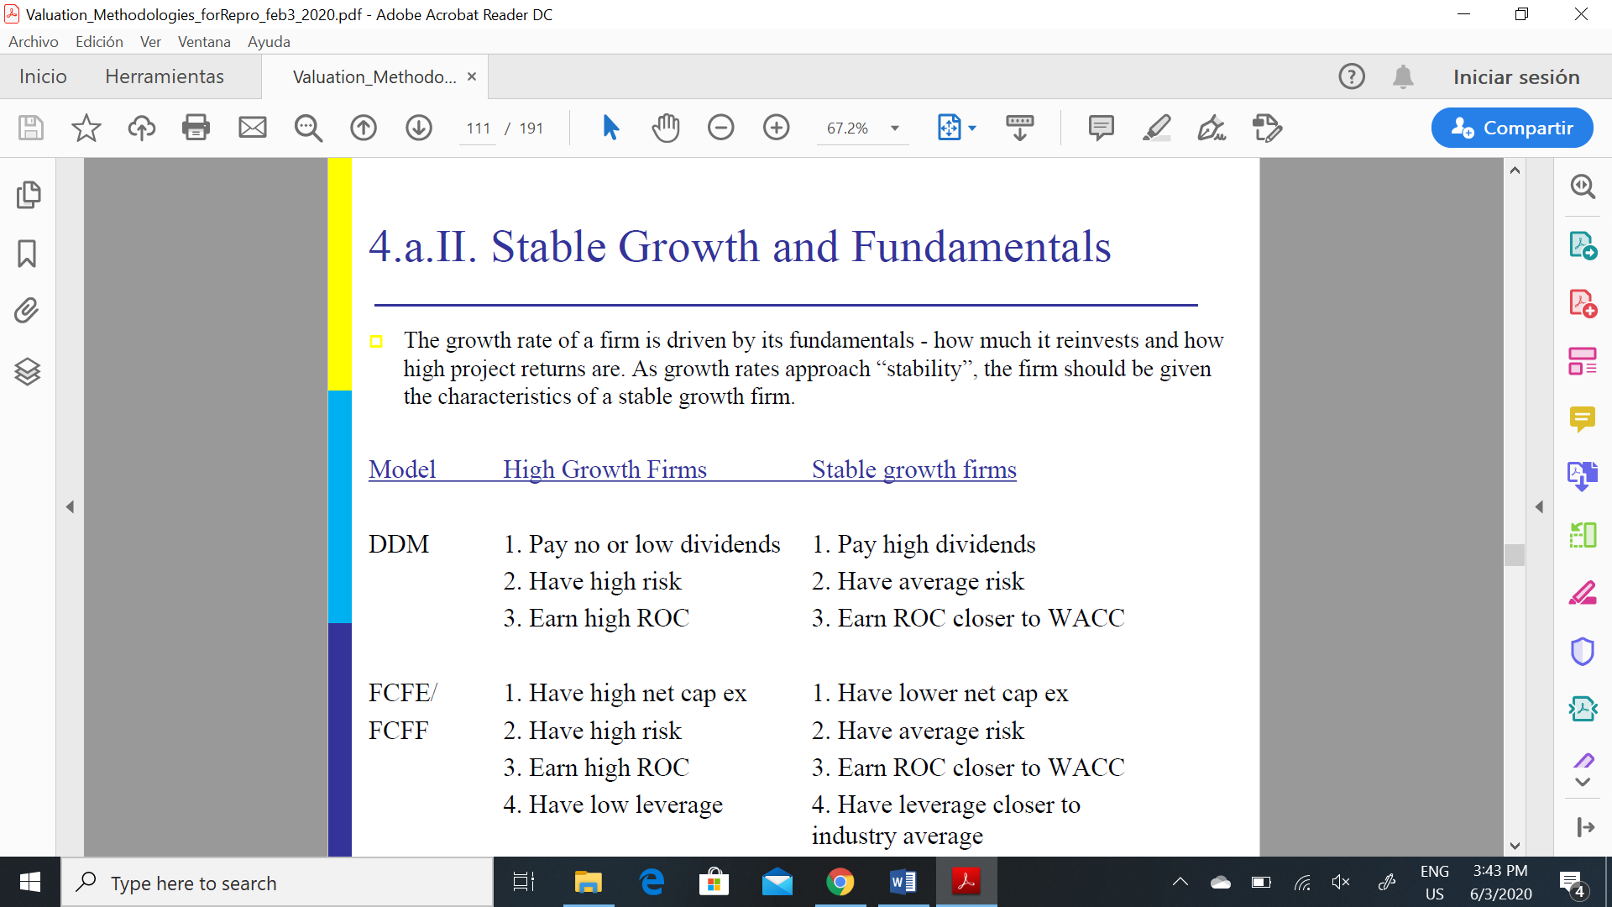

DISCOUNT RATE: WACC : It is a tax-adjusted discount rate that takes into account the value of the interest tax shields generated by the firm’s debt.

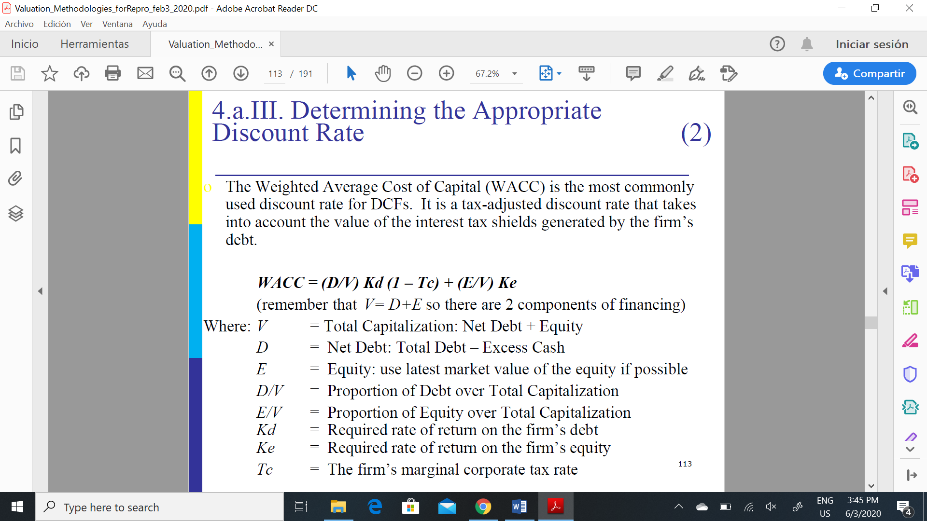

- D/V and E/V denote the capital structure of the firm. Ideally, this should be the long-term target capital structure of the firm

-Ke calculated using CAPM: 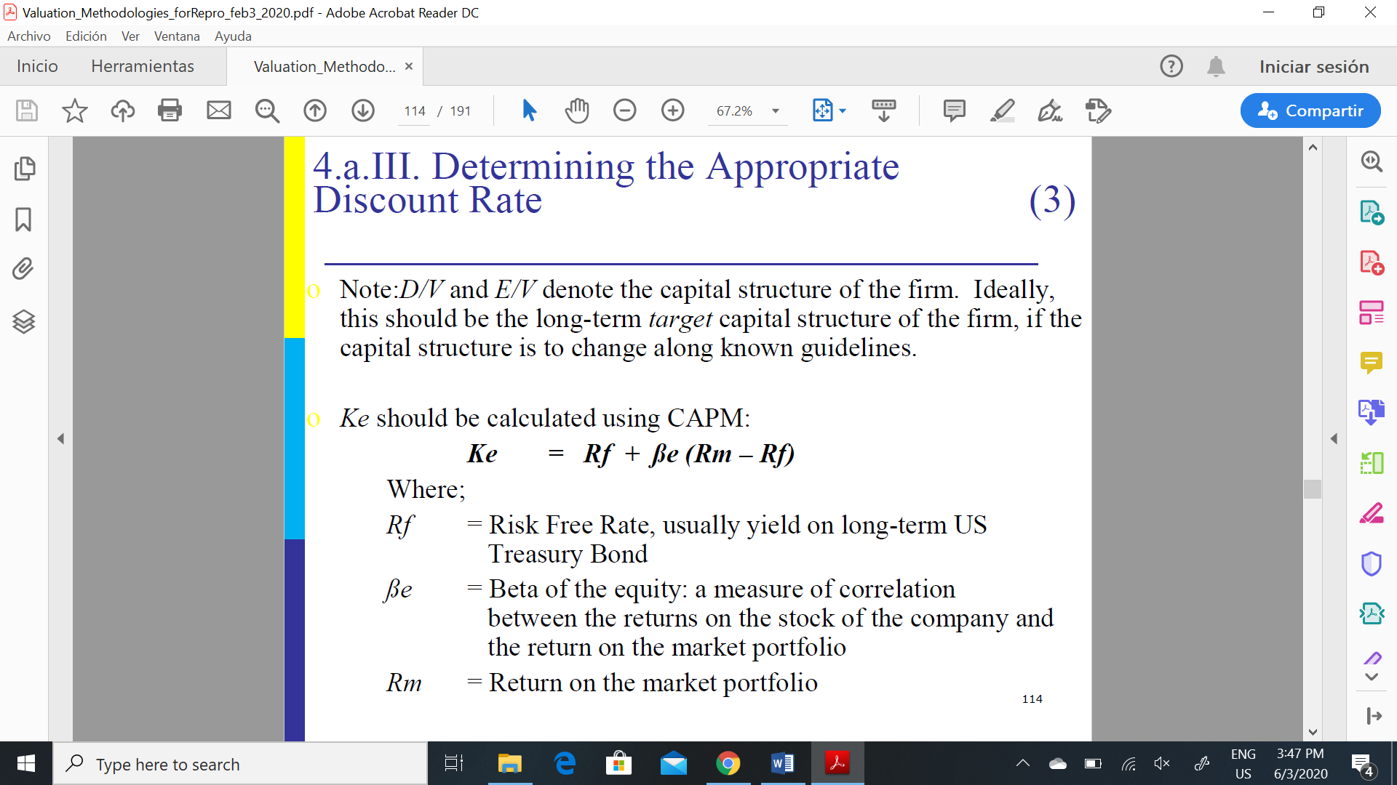

-Kd approximated by using the YTM of debt

- tax benefits of debt are included in the discount rate, the FCFs do not include the tax benefits of debt. FCFs are the cash flows that would be available to the firm if interest payment were not deductible

1. **CASH FLOW APPROACH (CCF):**

Capital Cash Flow = EBIT * (1 – tax rate)

+ Depreciation

- Change in Working Capital (Working Capital =

Current Assets – Current Liabilities)

- Capital Expenditures

=Free Cash Flow

+ Interest * Tax Rate (Tax shield)/Capital cash flow

Discount rate is the expected return on assets: Ka = Rf + ßa (Rm – Rf)

ßa = Beta of the assets: if only the beta of the equity is known then ßa can be found by “unlevering” ße: ßa = (E/V) ße. This is based on the formula ßa = (E/V) ße +

(D/V) ßd and assumes that the beta of the debt ßd = 0.

- difference with DCF is that CCF incorporate the tax shield for debt interest payments in the cash flows rather than in the discount rate.

*CCF method: ↑tax advantage 🡪 ↑CCF’s

*FCF method: ↑tax advantage 🡪 ↓discount rate (WACC)

- CCF methodology therefore provides a better measure of value when the capital structure is aggressive (high leverage), changing or unknown.

1. **EQUITY CASH FLOW APPROACH (ECF):** measure the cash flow available to stockholders after payments to debt holders are deducted from the operating cash flows and discounted at the cost of equity.

Equity Cash Flow = Capital Cash Flows - Interests and debt payments + Debt issues

Ke = Rf + ße (Rm – Rf)

Based on the formula ßa = (E/V) ße + (D/V) ßd and assuming that the beta of the debt ßd = 0 (debt has no systematic risk).

*The discount rate will be higher than for DCFs and CCFs because the equity cash flows are riskier as they come after payments to debt holders.

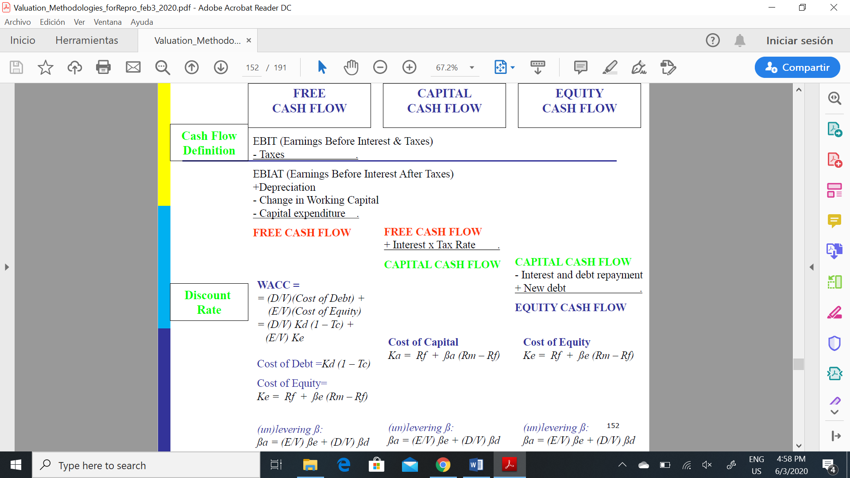

ADVANTAGES OF DCF VALUATION:

- based upon an asset’s fundamentals, it should be less exposed to market moods and perceptions.

- forces you to think about the underlying characteristics of the firm, and understand its business.

DISADVANTAGES OF DCF VALUATION:

- requires far more inputs and information than other valuation approaches

- inputs and information are not only noisy(and difficult to estimate), but can be manipulated by the savvy analyst to provide the conclusion he or she wants.

1. **VALUATION IN PARTS:** or Adjusted Present Value (APV) relies on the principle of value additivity.

Cash flows are separated into two main categories:

- (1) “Real” cash flows associated with the business operations, such as revenues, operating costs, and capital expenditures.

- (2) “Side Effects” associated with the financing program, such as the values of interest tax shields, subsidized financing, and hedges.

Total Value = (1) + (2) = PV of FCF + PV of Financial Costs and Benefits

⑴FCFs discounted at the all-equity cost of capital, rather than the WACC

⑵This can include several items, including the PV of tax shields and the value of financial subsidies

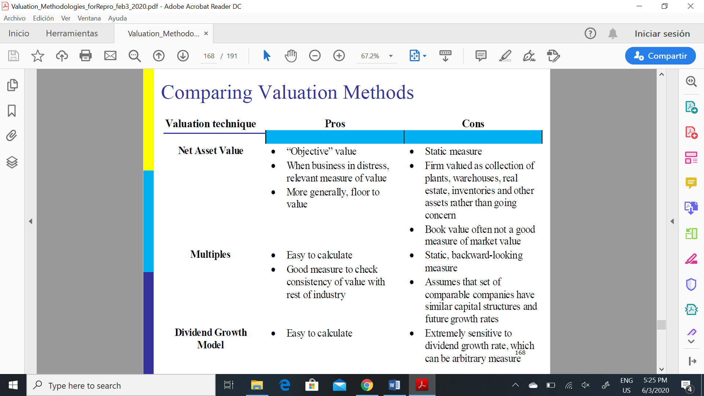

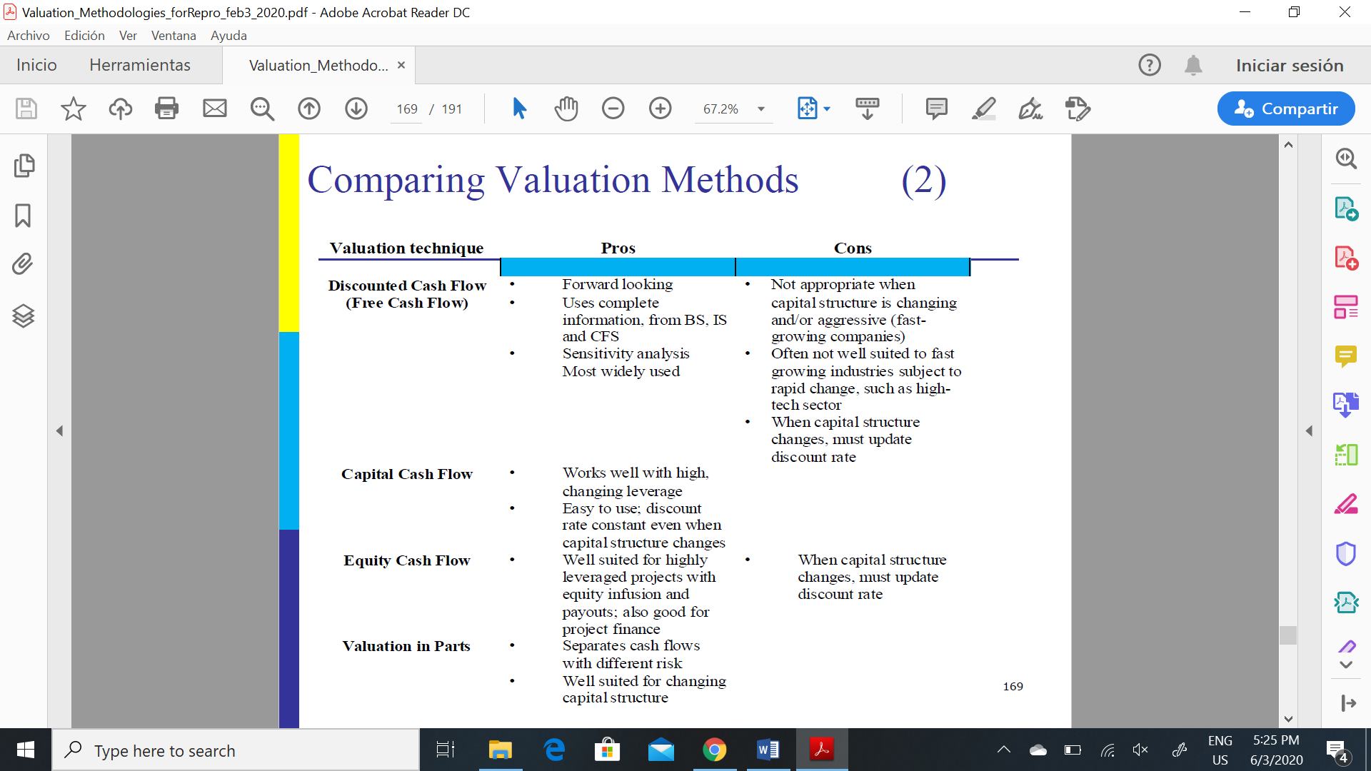

*Use equity valuation: firms which have stable leverage and if equity(stock) is being valued

*Use firm valuation: firms which have leverage which is too high or too low, and expect to change the leverage over time, you have partial information on leverage, more interested in valuing the firm than the equity

*Use dividend discount model: firms which pay dividends, firms where FCFE are difficult to estimate

* Use the FCFE Model: firms which pay dividends which are significantly higher or lower than the Free Cash Flow to Equity, firms where dividends are not available

* Use a Stable Growth Model If your firm is large and already growing at a rate close to or lower than the overall

* Use a 2-Stage Growth Model if your firm is large & growing at a moderate rate

* Use a 3-Stage Model If your firm is small and growing at a very high rate

**VALUATION OF PRIVATE COMPANIES:**

Private company owners are likely to be less diversified. Therefore, they bear both the market risk and the company-specific risk, increasing their cost of capital and decreasing the value of the firm to them.

The typical method of valuing a private company is to value it as if it is a public company and then apply a discount for the reasons stated earlier.

*Find a pure-play and use its WACC to discount the cash flows of the private company

*Pure-play is a public company that has the same business risk as the private company

*Or, use the multiples of a public company

AGENCY CONFLICTS:

***Agency Hypothesis***

* Shareholders may not be best qualified to run the firm, require specialized knowledge, shareholders (“principals”) hire a CEO (“agent”).
* CEO may not have sufficient financial resources to own the firm / may want a diversified portfolio.

***Agency problem:***

* Shareholders do not have full control over the CEO because they cannot write a complete contract (too many contingencies).
* The CEO has some control rights (ie, has discretion)

→can pursue goals other than maximizing shareholder’s wealth.

* *The separation of ownership and control is beneficial BUT COSTLY*

AGENCY CONFLICTS COME IN TWO FORMS:

1. An insider (controlling shareholder or manager) can simply transfer resources from the firm to his own benefit through self-dealing transactions
2. An insider can increase his share of the firm without transferring any assets.

***TRANSFER CORPORATE SOURCES TO THE INSIDER:***

1. **Taking corporate property:** abuse the assets (corporate property) such as plane

Special cases: opportunities (steal opportunities), information (insider trading), control (sell shares underpriced)

1. **Self dealing:** an insider owns 25% of Public Corp and 100% of Private Corp. The risk is that Public Corp will get cheated because the insider has a greater vested interest in ensuring the welfare of Private Corp than in Public Corp. (buying services at inflated prices from private corp). Eg. Aerolof case, which kept is revenues in Andava and had to borrow at high rates from companies owned by the CEO)
2. **Asset stripping:** sell the company’s assets to make some gain (the sale-and-leaseback of a building would lead to an increased rental bill for the company)
3. **Executive compensation:** There is a risk that compensation may be excessive due to Insider’s influence on Public’s decisions. Insider’s power over corporate decisions exist because of the weak influence of the Board of Directors in the setting of Executive Compensation.
4. **Mixed motives:** eg. Insider influences Public Corp to pay $50 M to buy the 20% of Public Corp recently acquired by Raider (“greenmail”). Raider had recently announced plans to gain control of Public Corp and change its business strategy. Danger: Public Corp may be paying an unfairly high price to preserve private benefits enjoyed by Insider (but not be minority shareholders). (Empire building. ↑Size → ↑CEO’s prestige, power and compensation.)

***DILUTING OUTSIDERS SHARE IN THE FIRM:***

1. **Going private:** Destroy company value (by stop dividends, de listing, stop value adding investments, etc) on purpose to go private so they can buy the shares at lower prices.
2. **Dilution:** eg. The Share Issues to off-shore companies controlled by the CEO at lower prices

**EVIDENCE ON AGENCY COST**

- Most of the evidence is “event studies”: Idea: If stock market falls when managers announce an action, then the action must serve the interest of managers and not of shareholders

**- Evidence from investment announcements:** the announcement of new explorations caused ⇓P since: (1) it cost $18 a barrel to explore for new oil resources; and (2) the cost of a proven reserve of a barrel of oil in the market was $6, (MARKET THINK IS A BAD IDEA BUT CEO STILL DOES IT)

**- Evidence from takeover resistance:** Mangers resist takeover to maintain its job. Managerial resistance to value-increasing takeovers is less when managers have share ownership and golden parachutes (benefits for CEO if employment terminates), or when they will keep their jobs.

**- Evidence on the death of founders:** sudden death–in plane crashes or from heart attacks–of founders is good news for shareholders perhaps because benefits of control diminish after the death of powerful managers

- **Evidence on voting premia:** people willing to pay for voting rights (in a country with low enforcement rights, you are willing to pay more for control). Control is valued around the world, which would NOT be the case if controlling managers received the same benefits as the rest of the investors. Shares with superior voting rights trade at a premium.

- **Simple model of tunneling:** In countries with low investor protection, insiders can use their control over corporate decisions to divert resources of the firm for their own benefit (hurting outside investors).

🡪 Tunneling is inefficient. Outside investors will put a lower value on the assets of the firm and insiders will bear the cost. As a result, insiders would like to find a way to commit to abstain from tunneling.

[s-c(k,s)]*R*I.

* The cost of tunneling c(k,s) increases as investor protection(k)improves and as the fraction of the profits that is being diverted (s) gets bigger.

The entrepreneur selects **s** to maximize:

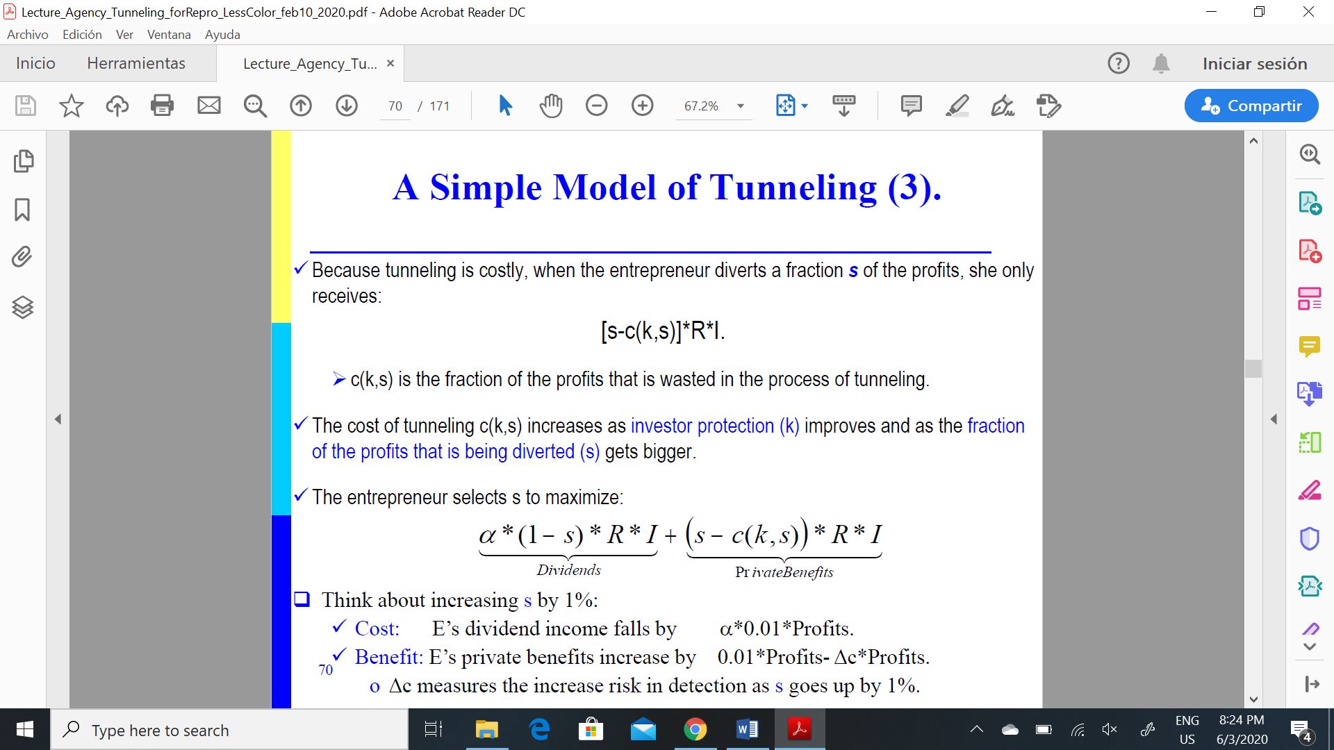

in equilibrium: (1-α) =Δc(k,s)/ Δs

s=value of the profits that entrepreneur diverts

c= costs of tunneling

Tunneling is low when:

1.α is high. The insiders bears a large fraction of the costs of cutting dividends.

2. Legal protection is strong (k ↑): Tunneling is less effective in such countries

SOLUTIONS TO AGENCY PROBLEMS: **Corporate Governance** deals with the constraints that insiders put on themselves, or that investors put on insiders, to mitigate agency problems and, thus, induce investors to invest more funds.

- **THE LAW:** The law and its enforcement are key mechanisms of investor protection. Strong investor protection leads to deeper financial markets & better financing terms for firms.

Control rights (shareholder rights and creditor rights) + Enforcement rights (efficiency of the judiciary and accounting standards)

*Common law countries a bit better in all 4 dimensions mentioned above.

*Investor protection should be associated with higher number of listed firms and higher valuation of capital and larger private credit and bond markets, lower private benefits, ownership concentration and earnings manipulations.

*investors willing to pay 20% more due to better shareholder protection

- **DEBT:** Debt can be used to limit the availability of FCF to managers and commit them to a repayment schedule. Optimal level of debt trades off the cost of wasting resources in NPV<0 against the benefit of avoiding costly liquidation. (power of debt depends on the country due to creditor protection)

- **DIVIDENDS:** Similar to debt but with less commitment. Unless there is a large cost to cutting dividends, dividends are not as much a commitment as debt.

*Outcome Theory: Dividends are a result of good legal protections

*Substitution Theory: dividends stablish reputation; we would expect to see countries with poor legal protections paying more dividends (to attract investors).

- **BOARDS OF DIRECTORS:** Statistical evidence suggests boards don’t do anything, and usually collude with the CEO. Boards act when firm performance lags that of industry peers. The probability of getting fired is low when all firms in an industry are doing poorly.

*International Evidence: They are likely to collude because the board has only family.

- **LABOR MARKET:** not enough evidence to show that markets penalize bad managers (bad managers obtained other directorships in spite of their performance)

- **MANEGERIAL OWNERSHIP:** Align interests of managers and shareholders. If you have a high alpha in the firm is like stealing from yourself.

- **INCENTIVE CONTRACTS:** Pay-for-performance may align managerial incentives with those of shareholders. Pay-per-performance mitigates the incentives to undertake actions with mixed motives (eg, bad acquisitions). It does little to avoid taking-of-property problems and conflicts of interest.

- **LARGE CREDITORS:** Banks are important investors in some countries. The have the power: (1) to throw the firm into bankruptcy; and (2) undertake short-term lending.

- **LARGE SHAREHOLDERS:** Evidence that play an active role: ⇑turnover of directors, ⇑likelihood that a firm is taken over, more likely to replace managers in response to poor performance

\***Jawboning:** (abuse of position) Benefits of large investors: Incentives to monitor (≠free-rider problem).

\***Activist investor:** help depose the CEO, fight for break up, won board seats (activist are growing)

\***Proxy fights:** (fights for votes) Shareholder meeting where an opposition candidate runs.

\***Takeovers:** Poor management →low earnings →low stock price: It may attractive to buy the firm and fire the manager. Evidence: Stock prices rise when a takeover is announced.

Problems: expensive, can increase agency costs, require liquid capital market, politically vulnerable

Wrap up: large outside shareholders: management turnover is more sensitive to performance, high valuation multiples. Large majority shareholders (>51%) can influence easily and its effectiveness depends on coalitions they make

DEBT AND INCENTIVES

Key Idea: Leverage may change the value of the firm by altering the incentives of those making investment decisions (i.e, the size of the pie may depend on how it is shared).

1.Debt may increase firm value by deterring “bad” investment; or

2.Debt may decrease firm value by curtailing “good” investment.

The interests of shareholders and those of managers are not always perfectly aligned. Potential problems include: **(agency problems)**

* Reduced effort;
* Perks; and
* Empire building.

Michael Jensen’s basic idea: Managers may pursue bad investments rather than give shareholders their cash back. 🡪 **Debt** can be used to limit the availability of Free CF to managers and commit them to a repayment schedule. The idea is that is the firm's free cash flow is dedicated for a payout, such as interest payments, managers will not be able to use this free cash flow to pursue negative NPV projects they like for fear of bankruptcy. (eg. *Leveraged recapitalization* largely increases the value of the company)

FCF EXAMPLE: Managers come in two flavors: (1) “Good” managers (only pursue NPV>0); and (2) “Empire builders” (pursue NPV>0 andNPV<0).

**The Conflict of Interest between Debtholders and Stockholders**

* Equity-holders (who have the votes) to make investment decisions that increase their share of the firm’s cash flows at the expense of bondholders (while possibly decreasing the total value of cash flows available).

* games between stockholders and bondholders lead to inefficient investment decisions. This means that capital structure can have real effects by distorting real investment decisions.

* Financial distress may induce managers to destroy value. Examples:

1.Excessive risk taking (“gambling for resurrection”);

2.Shareholders may refuse to contribute fresh funds to finance NPV>0 when their equity has low value (debt overhang)

3.Delay of efficient liquidation (risk shifting); and

4.Cash-in-and-run –Leave creditors with an empty shell.

**RISK SHIFTING:**

**-** Unlevered firm: incentives are aligned (max firm value= max shareholder value)

- NOW: add debt with face value F. When the value of the firm is close to F, shareholders capture most of the upside but little of the downside 🡪 may induce them to gamble by taking risky negative NPV projects. (equity holders have little to lose)

**DEBT OVERHANG:**

- Underinvestment Problem: Shareholders may be reluctant to contribute fresh funds to finance NPV>0 when their equity has low value because they may be throwing good money after bad one.

- The problem goes away if creditors forgive some part of the debt.

- The problem also goes away if creditors contribute new capital to pay for project.

-Practical Implication: Firms that expect to have valuable future growth opportunities should avoid too much debt.

**CASH-IN-AND-RUN:**

- Leave creditors with an empty shell by paying a large dividend or repurchasing a large number of shares.

**PLAY FOR TIME:**

-Shareholders may try to maximize the value of their option.

-Their hope is that, given more time, the firm’s cash flows will have greater change of bouncing back and leaving them with a positive net worth.

-It takes multiple forms. Examples: Misleading accounting; Reluctance to invest in the business when default is possible; Swaps of equity for debt in default; Delay the resolution of insolvency

**BAIT AND SWITCH:**

- An unexpected increase in D/E.

- Split company into two separate entities: (1) Lodging and service management; and (2) Real estate holdings

- Put most of the debt on the balance sheet of the real estate firm & spin off the lodging assets to shareholders →expropriate growth opportunities →bondholders forgot to include covenants against such transactions. (Increase share prices)

***SOLUTIONS:***

* Raise the cost of debt: Bondholders will react by raising the required rate of return on bonds. Because shareholders have to pay these higher interest costs, they ultimately bear the costs of the investment distortions imposed by debt.
* Bond covenants: Long-term financiers may require additional support from shareholders to enter into a long-term financing agreement, such as restrictions on dividend payments, additional leverage, collateral structures and so forth.

Types:

1. Restrictions on subsequent financing: (bait and switch) Issuance of new debt prohibited unless certain ratios are met. Restrictions on the issuance of secured debt
2. Restriction on dividends: (cash in and run) Allow payments of dividends only if sufficient payable funds exist.
3. Restriction on merger activity (Poison Puts): (risk shifting) Bondholder has the right to sell the bond back to company at some given price if some specific event (such as a takeover) occurs.
4. Restriction on disposition of assets: (risk shifting, cash in and run) restrictions on asset sales unless used to retire debt, restrictions on investment in financial securities, which prevent stockholders from increasing risk
5. Restriction on net worth: Mandatory debt retirement at par if net worth falls below specified minimum

Caveat: Having too many covenants may also be costly since it can severely restrict the flexibility of firms to make investment, financing, or dividend decisions.

* Other:

1. Delegated monitoring: have a “close” lender offering short-term debt and monitoring the firm on behalf of itself and other creditors. Such lender would have more “control” over the borrower's activities because it could always threaten not to renew its loan to the firm.
2. Security design: bondholders a piece of the pie if things go well. Contracts like convertibles may mitigate the risk-shifting problem. Debt holders will convert if risky projects pay off.
3. Management compensation contracts: can be structured so that management takes the interests of all claim-holders into account.
4. Reputation. If you plan to be an entrepreneur or an executive for a long time, you don’t want to go around reneging on your contracts and disappointing creditors.

TO REMEMBER:

- the way the CF is divided between shareholders and creditors may affect the firm’s investment policy (and thus change its CFs and value).

- However, it is quite plausible that investment may directly be affected by capital structure.

*Leverage may reduce wasteful investments. It may also induce managers and employees to work harder.

*If the value of the firm is close to the face value of debt, shareholders may invest in NPV<0 projects with high upside profits.

*If the value of the firm is lower than the face value of debt, shareholders will not want to invest fresh funds in NPV>0 projects as they will eventually loose their equity in the firm (even if the new projects succeed).

-addition, investment may indirectly be affected by capital structure.

*Shareholders may cash-in and run by awarding themselves large dividends.

*Shareholders can resort to many other methods to separate creditors from their money, such as play for time, bait and switch, etc.

*Creditors will anticipate this behavior and demand higher interest rates. As a result, fewer NPV>0 will be pursued.

Debt Collection under Financial Distress and Bankruptcy

Costs of Financial Distress and the Value of Claims:

- Taxes, financial distress, and bankruptcy costs can be viewed as just another claim on the cash flows of the firm.

VT= Shareholders + Bondholders + Government + Lawyers

-The essence of the M&M intuition is that VT depends on the cash flow of the firm; capital structure just slices the pie.

*-But if Investment Policy is NOT fixed, then the size of the pie changes!!!*

**Financial distress:**

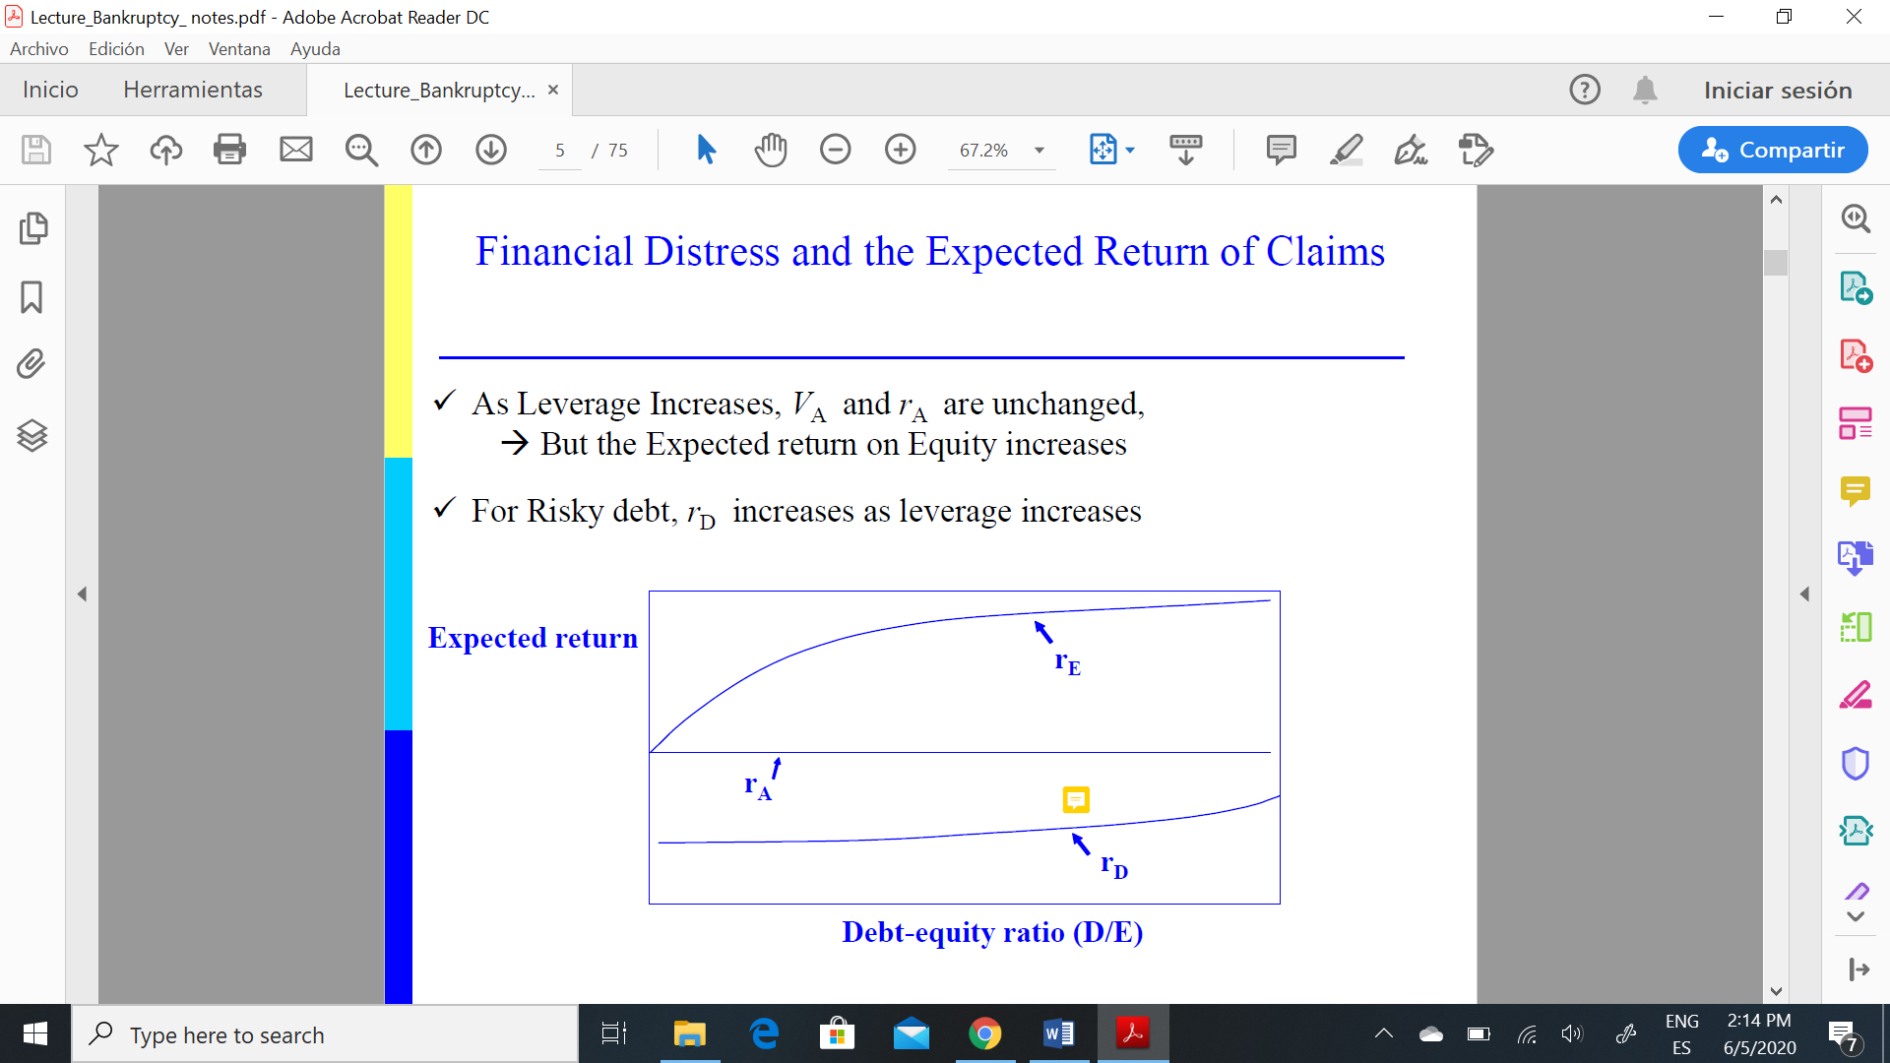

What is Financial Distress?

-A situation where a firm’s operating cash flows are not sufficient to satisfy current obligations and the firm is forced to take corrective action.

-Financial distress may lead a firm to default on a contract, and it may involve financial restructuring between the firm, its creditors, and its equity investors.

What happens in Financial Distress?

-Financial distress does not usually result in the firm’s death

- **Asset Restructuring**: Selling major assets, Merging, Reducing capital spending and R&D spending.

- **Financial Restructuring:** Issuing new securities, negotiating with creditors, Exchanging debt for equity, Filing for bankruptcy.

COST OF FINANCIAL DISTRESS:

- Direct Costs: Legal and administrative costs [≈ 3-5 % of the value of the firm]

- Indirect Costs [≥15-20 % of the value of the firm]

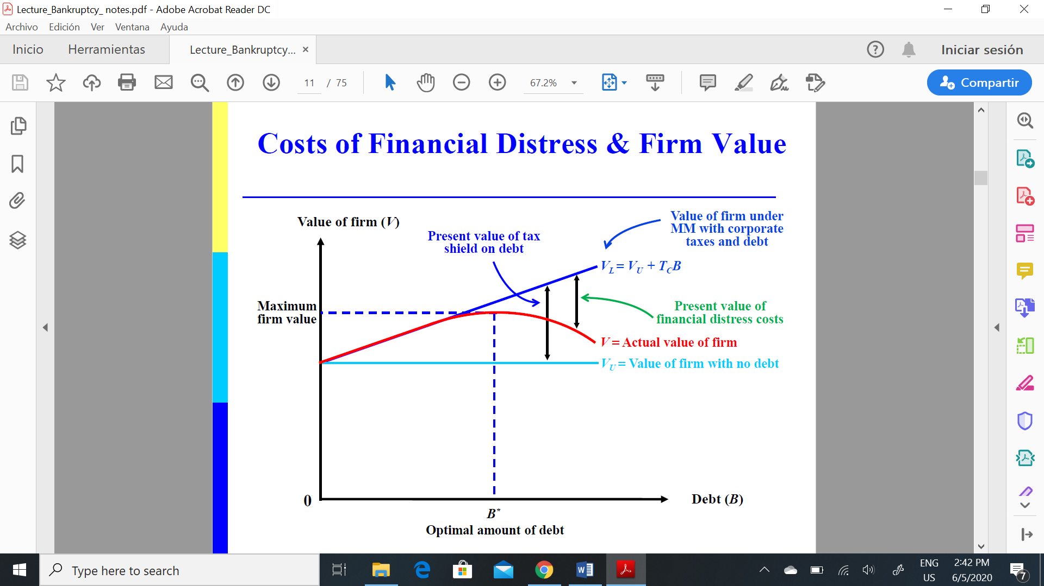

**INSOLVENCY:**

-Corporations are in Bankruptcy when they cannot pay the financial claims of creditors, may arise because of insolvency or illiquidity. Bankruptcy may be initiated by either the creditors or the debtors.

- Insolvency: The sum of the claims of the creditors exceeds the value of the assets.

- Illiquidity: The value of the assets exceeds the value of creditor claims, but there is a temporary shortage of cash required to pay them.

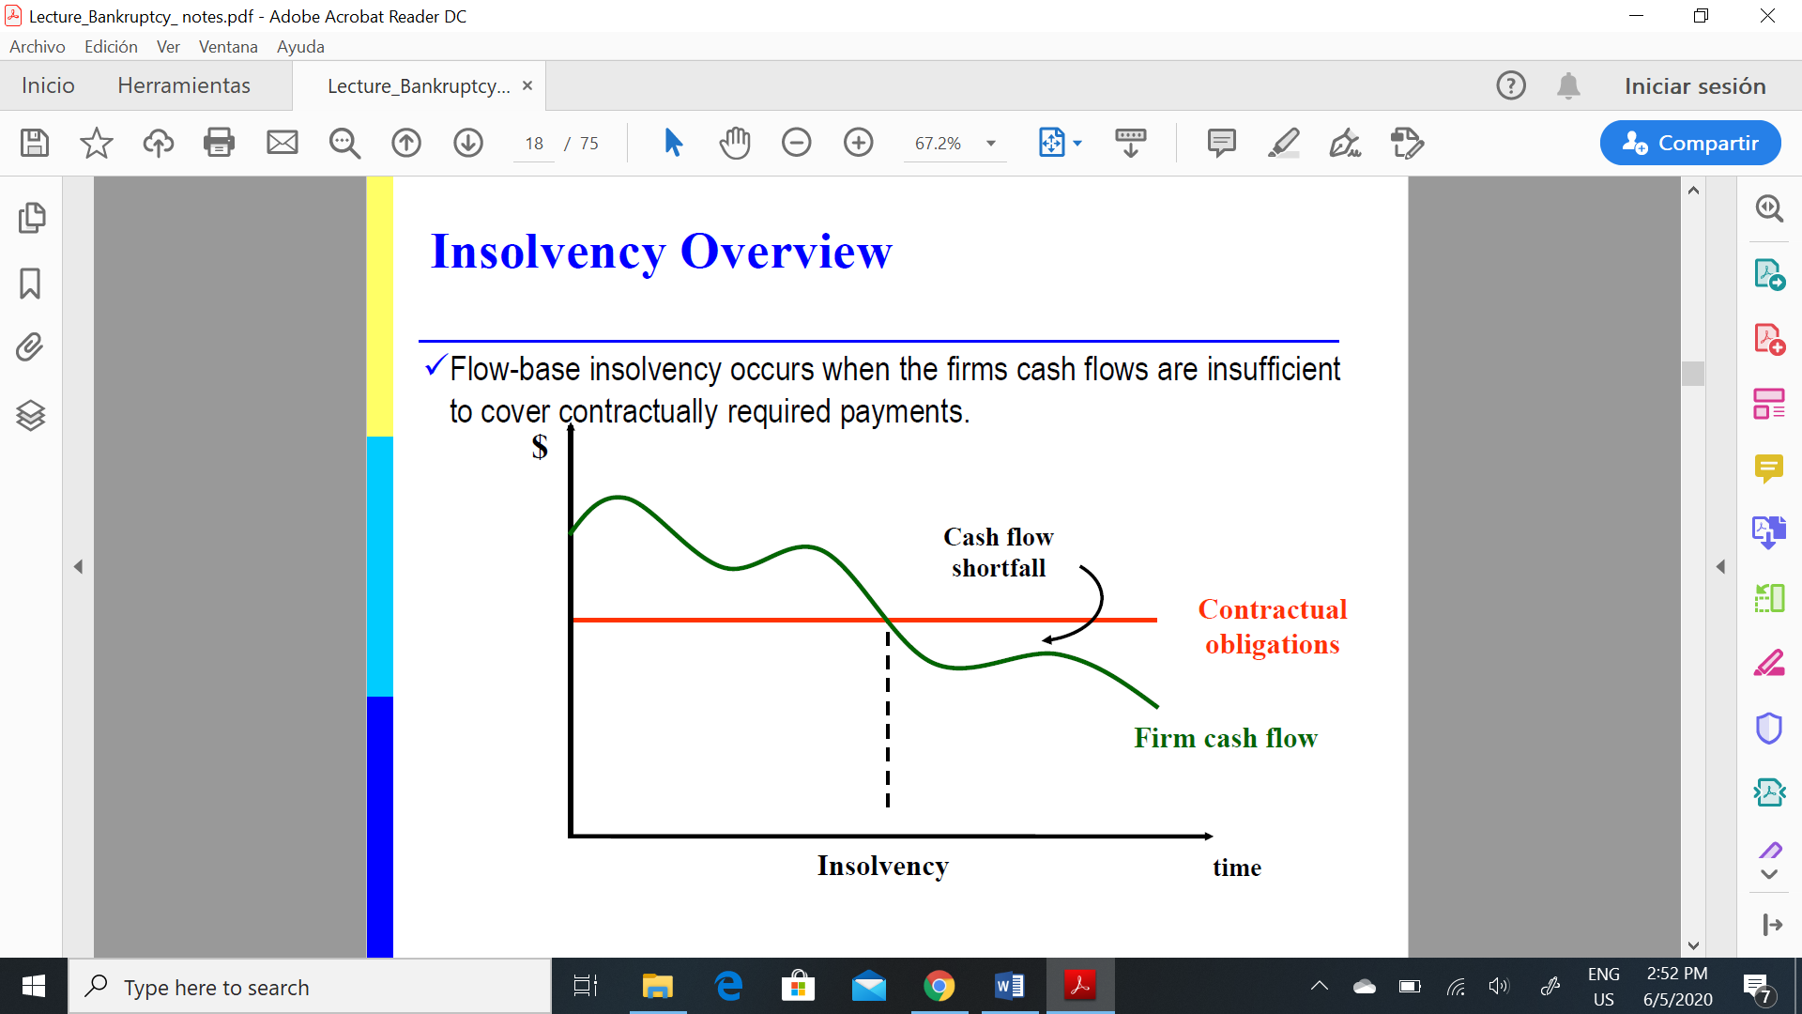

Z-SCORE MODEL TO PREDICT BANKRUPCY:

- lenders use credit scoring models to assess the creditworthiness of prospective borrowers.

- find factors that enable the lenders to discriminate between good and bad credit risks.

- Edward Altman has developed a model using financial statement ratios and multiple discriminant analyses to predict bankruptcy **for publicly traded manufacturing firms.** His model is of the form:

Z = 3.3(EBIT/Total assets) + 1.2(Net working capital/Total assets) + 1.0(Sales/Total assets) + 0.6(Market value of equity/Book value of debt) + 1.4(Accumulated retained earnings/Total assets)

where Z is an index of bankruptcy.

- Bankruptcy would be predicted if Z ≤1.81 and non-bankruptcy if Z ≥2.99.

- revised model to make it applicable for **private firms and non-manufacturers:**

Z = 6.56(Net working capital/Total assets) + 3.26(Accumulated retained earnings/Total assets) + 1.05(EBIT/Total assets) + 6.72(Book value of equity/Total liabilities)

where Z <1.23 indicates a bankruptcy prediction.

1.23 ≥Z ≤2.90 indicates a grey area,

and Z >2.90 indicates no bankruptcy.

- two main procedures to deal with bankruptcy problem: Liquidation & Reorganization

**Incentives of Debtors and Creditors**

- Inefficient liquidation: When there are many creditors, they may rush to liquidate collateral inefficiently

- Good bankruptcy procedure protects firms from scenarios like this.

- good bankruptcy procedure strikes a balance between reorganization and liquidation.

**Creditor Protection**

- Creditor protected by bankruptcy laws

- More creditor protection, bigger creditors market

- *enforceability* of laws is a prerequisite for working creditor protections

- Economic theory suggests two determinants of how much private credit a financial system would extend to firms and individuals:

1. Power theories: What matters for the viability of private credit is the power of creditors. When lenders can more easily force repayment, grab collateral, or even gain control of the firm, they are more willing to extend credit.

2. Information theories: What matters for lending is information. When lenders know more about borrowers, their credit history, or other lenders to the firm, they are not as concerned about the lemons problem of financing nonviable projects and therefore extend more credit.

- *What’s wrong with current Bankruptcy Procedures?* Senior creditors may prefer to liquidate and junior creditors prefer to reorganize (people decide based on their own share of the pie rather than all).

* Coase Theorem: claimants could bargain around these inefficiencies and get around them by buying out each other. (may not happen in real life because there are many claimants)

**Private workout or bankruptcy?**

- Prepackaged Bankruptcy:

*A combination of a private workout and legal bankruptcy.

*The firm and most of its creditors agree to private reorganization outside the formal bankruptcy.

*After the private reorganization is put together (prepackaged) the firm files a formal bankruptcy.

*The main benefit is that it forces holdouts to accept a bankruptcy reorganization.

*Offers many of the advantages of a formal bankruptcy, but is more efficient.

(1) Court-run procedures: In countries with low efficiency of the judicial system, court-intensive procedures may impose substantial deadweight loses which prevent solvent firms from undertaking some positive NPV projects.

(2) Creditor-run procedures: Creditors appoint an administrative receiver in charge of: running the firm in default, disposing of its assets piecemeal or as an ongoing operation and, distribute the proceeds in accordance with absolute priority.

Advantages: Quick, therefore minimizing the firm’s loss of value, and minimizes the intervention from the court (police vs. fraud).

Disadvantages: Might not be interested in maximizing the firm’s value, May favor some creditors over others

(3) Market-run Procedures: (Contract theory, Hart & Holmstrom). Disassociates decision on allocations of assets from decision on who gets what. Kill all claims 🡪 create a claim 🡪 people have shares instead of claims (claims changes by shares) 🡪 vote for the best reorganization offer

Advantages: It is cheap, quick, and minimizes the reliance on the judicial process. Achieves the “fair outcome” in terms of absolute priority, Eliminates conflicts between different classes regarding the future of the firm since all holders of Bankruptcy Rights are equal and have only one objective: to maximize the value of firm.

MERGERS AND ACQUISITIONS:

- Bristol-Myers Squibb + Celgene (largest acquisition of 2019)

- M&A activity has increased substantially since the mid-1960s.

**MERGER.**

- Two (or more) corporations come together to form one new entity.

- The acquirer assumes all assets (that can legally be transferred) and all liabilities.

- They are negotiated deals. Very likely to be friendly. Closing likely to take 5 months.

- They require the approval of both management teams/boards before stockholders vote.

- Big mergers require the approval of the acquirer’s shareholders if stock is to be issued.

- Sometimes this can be avoided using a “triangular” merger (i.e., acquirer creates a wholly-owned subsidiary which in turn makes the acquisition). Wholly-owned subsidiaries are also used to limit potential liability.

- They are not-taxable events for the target shareholders (unless they later sell).

- The shareholders of the combining firms often remain as joint owners of the combined entity.

**ACQUISITION**

- One firm purchases the assets or shares of another (“target”).

- The shareholders of the target cease to be owners of that firm.

- The target becomes a subsidiary of the acquirer.

- They usually take the form of a *public tender offering. (take over bid)*

- A successful acquisition offer made directly to a firm’s management is a friendly takeover.

**TAKEOVER=acquisition**

- Generic term. Includes both mergers and tender offers. The “bidder” in a takeover purchases the assets or shares of a “target” firm.

- In *a hostile takeover*, the bidder makes a tender offer for the shares of the target without the consent of its management.

**TENDER OFFER.**

- The bidder makes a direct offer to the target’s shareholders to buy their shares at the offer price on a given date.

- They are taxable events for the target shareholders.

- The bidder is typically under strong pressure to complete the transaction quickly before competing bidders are able to respond.

- Conditional vs unconditional: eg. conditional on obtaining x% of the shares of the target

- Restricted vs unrestricted: eg. restricted pre-specifies the % of shares to be acquired by the bidder

**Approaches to Acquisitions.**

- The friendly approach: Bidder informally approaches target with a view towards a negotiated transaction.

- The bear hug: Write a letter with formal acquisition proposal to the board of the target, Used if the friendly approach is inappropriate or after an unsuccessful friendly approach.

- The hostile approach: Proxy fights and Tender offers

**SOURCES OF VALUE IN M&A.**

- Companies willing to pay premium of 35-40% for m&a

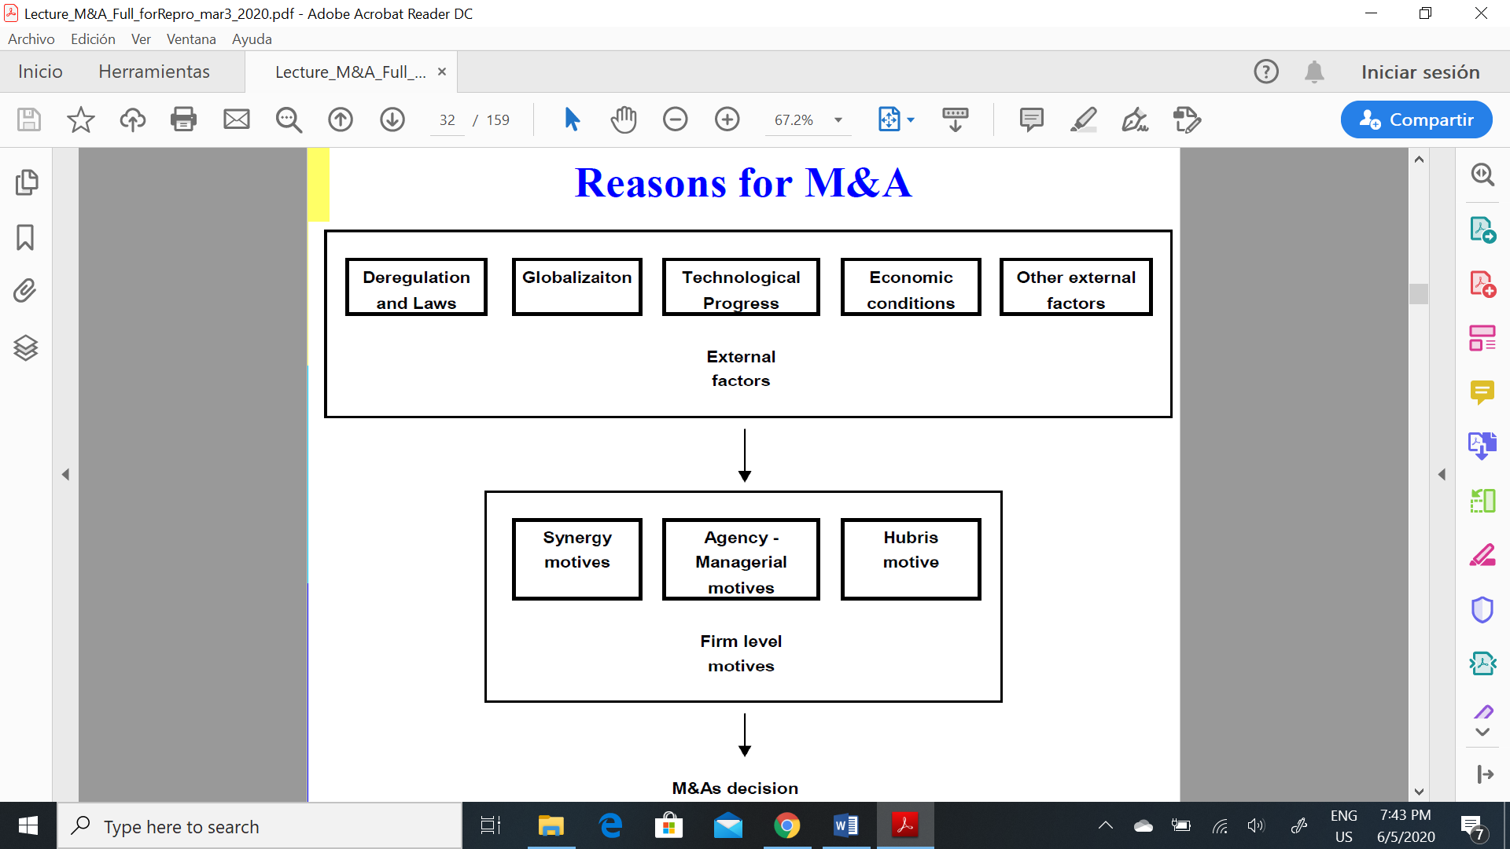

- M&As create efficiency gains ↑Revenues and/or ↓Costs: Operating synergies, Tax savings, Target may be poorly run.

- M&As reduce the cost of capital: Financial synergies, Take advantage of deviations of stock prices from fundamentals.

- Bidders expropriate stakeholders (e.g., workers, creditors) of the target firm.

- Bidders overpay because of agency problems (not managers money so they don’t care overpaying) or overconfidence (“hubris”).

**Operating synergies**

(a) Horizontal Mergers: Merger of competitors (ie, firms producing similar products in similar markets). They allow firms to exploit economies of scale or to cut over-capacity. BUT They increase market power by reducing competition.

(b) Vertical Mergers: Upstream firm buys a downstream firm (or vice versa).

Benefits: Reduce transaction costs and improve coordination.

Costs: Agents seek to influence decision-maker.

(c) Conglomerate Mergers: Firms in totally different industries

(d) Related Mergers: Firms in related businesses can share resources (e.g., distribution networks).

**Tax savings**

- Acquiring firms often increase total leverage in the course of executing the transaction. (more tax shield)

**Target may be poorly run**

- Firms run by managers that do not maximize shareholder value become takeover targets.

- Acquiring banks can increase their business and revenue using the resources of the target to expand loans and other business lines, if the resources were underused or there was no sufficient capital

**-** The lower the ROA the highest the probability of being acquired

**Financial Synergies**

- Bad reason: diversification reduces the risk of the bidder’s stock. But: Shareholders could achieve diversification by themselves.

- Better reason: pecking-order model →internal capital market is valuable →merge cash-rich and cash-starved firm and forego fewer NPV>0.

**Deviations from market efficiency:**

**-** Target may be undervalued (undervalued assets): The bidder may have private information about the value of the target.

- Bidder may be overvalued (overvalued stock): bidder may benefit from making an acquisition, even if the target is also overvalued, if it can pay with overvalued equity.

**Expropriate other Stakeholders**

- Expropriation of “old” bondholders:Leveraged Buyout increase the risk of old debt without increasing their promised interest payments.

- Expropriation of employees: easier layoffs & reduction in over-funded pension plan (reduce salaries)

**Management Overpayment**

- Managers may overpay for one of two reasons: Hubris (overconfidence)

- Managerial objectives: Managers do not maximize shareholder value. Rather they pursue private benefits.

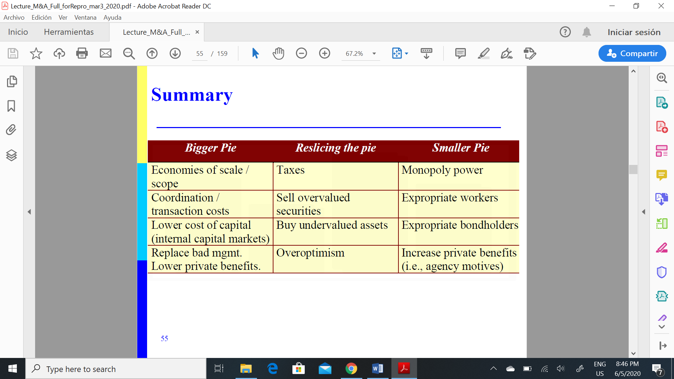

**STYLIZED FACTS ABOUT M&A**

1. Combined gains always positive but small: Abnormal Ret [-1,+1] = 0 to 1.5%, Evidence supports the existence of synergies.

2. Targets do better than acquirers:

- Targets: Abnormal Ret [-1,+1] = around 15%, Abnormal Ret [-20,close] = around 20%.

- Acquirers: Abnormal Ret [-1,+1] = around -1%, Abnormal Ret [-20,close] = around -2%.

3. Acquirers’ stock reacts more negatively when stock is the currency and bidders are large public

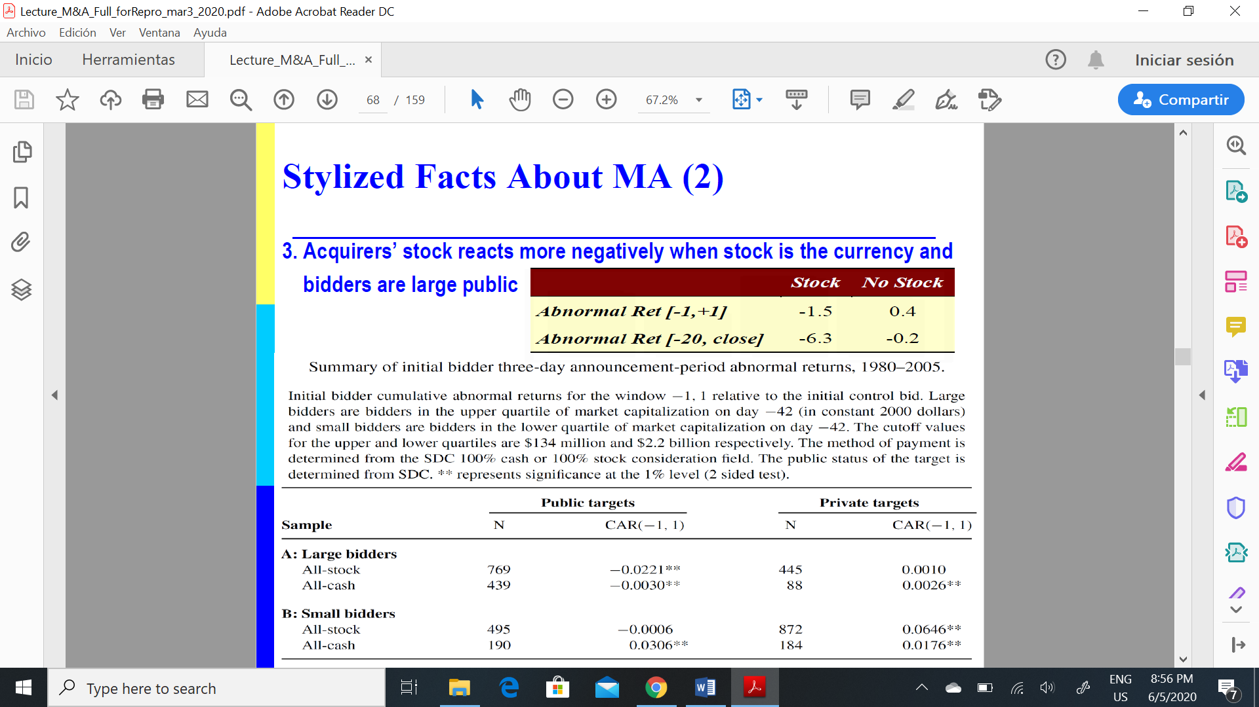

4. Diversification leads to lower returns for the bidder: Conglomerates trade at a 15-20% discount to the sum of the stand-alone value of each of their businesses.

5. Firms perform poorly in the post-merger period

- Negative long-run performance for mergers

- Non-negative (perhaps positive) for tender offers

MACRO FACTS???

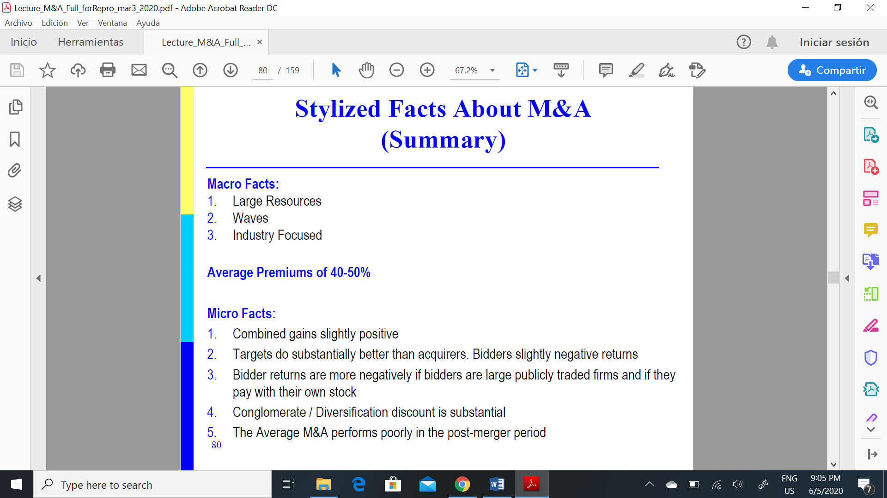

**EXPLANATIONS FOR THE STYLIZED FACTS:**

**1.The Free-rider problem:** The free rider problem may explain *why most of the gains from takeovers accrue to the shareholders of the target*.If there is a conditional tender offer higher than the share price but lower than after merger, individual shareholders will not tender hopping that the others will tender so they can benefit from the price increase after the merger occurs. 🡪 all shareholders think the same so value enhancing takeover will not happen.

- How can the raider make a profit on the transaction? Make offer to large investors; Unconditional bids; Two-tier offer; Freezouts; and Looting.

**2.Managerial overpayment.**

- Acquirers buying outside their main lines of business do significantly worse than those that stay in their area of expertise (lower expected return)

- Hubris should be more likely in related acquisitions (the managers’ field of expertise) than in unrelated ones.

- This fact is consistent with the managerial motives hypothesis (acquisitions are bad because management is bad).

- Acquiring firms in which management owns little stock make the worst acquisitions (consistent with the managerial-motives hypothesis).

**THE REASONS FOR M&A FAILURES**

**Why acquirers overpay?**

- Acquirers are over optimistic in their assumptions (e.g., too high growth).

- Acquirers overestimate the synergies.

- The Winner’s curse: in the heat of the deal, the acquirer bids up the price beyond the limit of reasonable valuations

- Failed deals damage the credibility of the acquirer’s managers and the coherence of the firm’s strategy.

**Why do acquisitions fail?**

- The acquisition is considered successful if in 3 years it earned its cost of equity capital or better on funds invested in the acquisition program

•Greatest chance for success: small and related businesses

•Greatest chance of failure: unrelated and large programs

🡪Therefore, diversification might not be a good motive for M&A (in terms of recouping investment)

- M&A benefit from geographic overlap, may be as a result of synergies in: 1) Consolidation of production facilities; 2) Integration of distribution networks, 3) Reorganization of sales force

- Part of the failures comes from: Diversifying acquisitions (Do not know how to value and run them), Little geographic overlap, Weak performance of core before.

- Summary of success: Small and related, Strong core beforehand, high geographic overlap

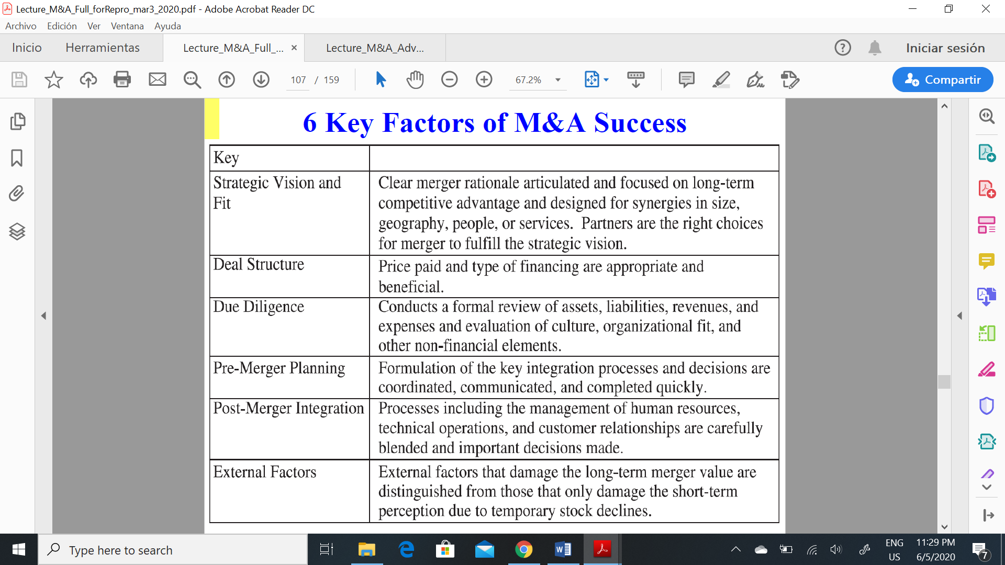

**M&A VALUATION**

Evaluating a potential acquisition is similar in most respects to analyzing the NPV of any other investment project a firm may be considering.

There are, however, some subtle *differences*:

1.The value of potential synergies must be added to the value of the target firm's cash flows.

2.The target firm's stock price will exceed the present value of the firm's future cash flows under current management if it reflects the possibility that the firm may eventually be taken over at a premium.

**Stock vs cash payments**

**-** Three methods of payment in a public M&A:All cash**,** All stock**,** Combination of cash and stock

- Collar: Stock bid with a ceiling and floor on the potential stock price of the acquirer.

*Fixed exchange: Constant exchange ratio of stocks over a range of bidder stock prices, cash adjustments when bidder stock price crosses a boundary.

*Fixed payment: Target shareholders receive a fixed cash payment when the bidder’s stock value is in some range, and a fixed exchange ratio (stock for stock) if the bidder stock price is outside that range.

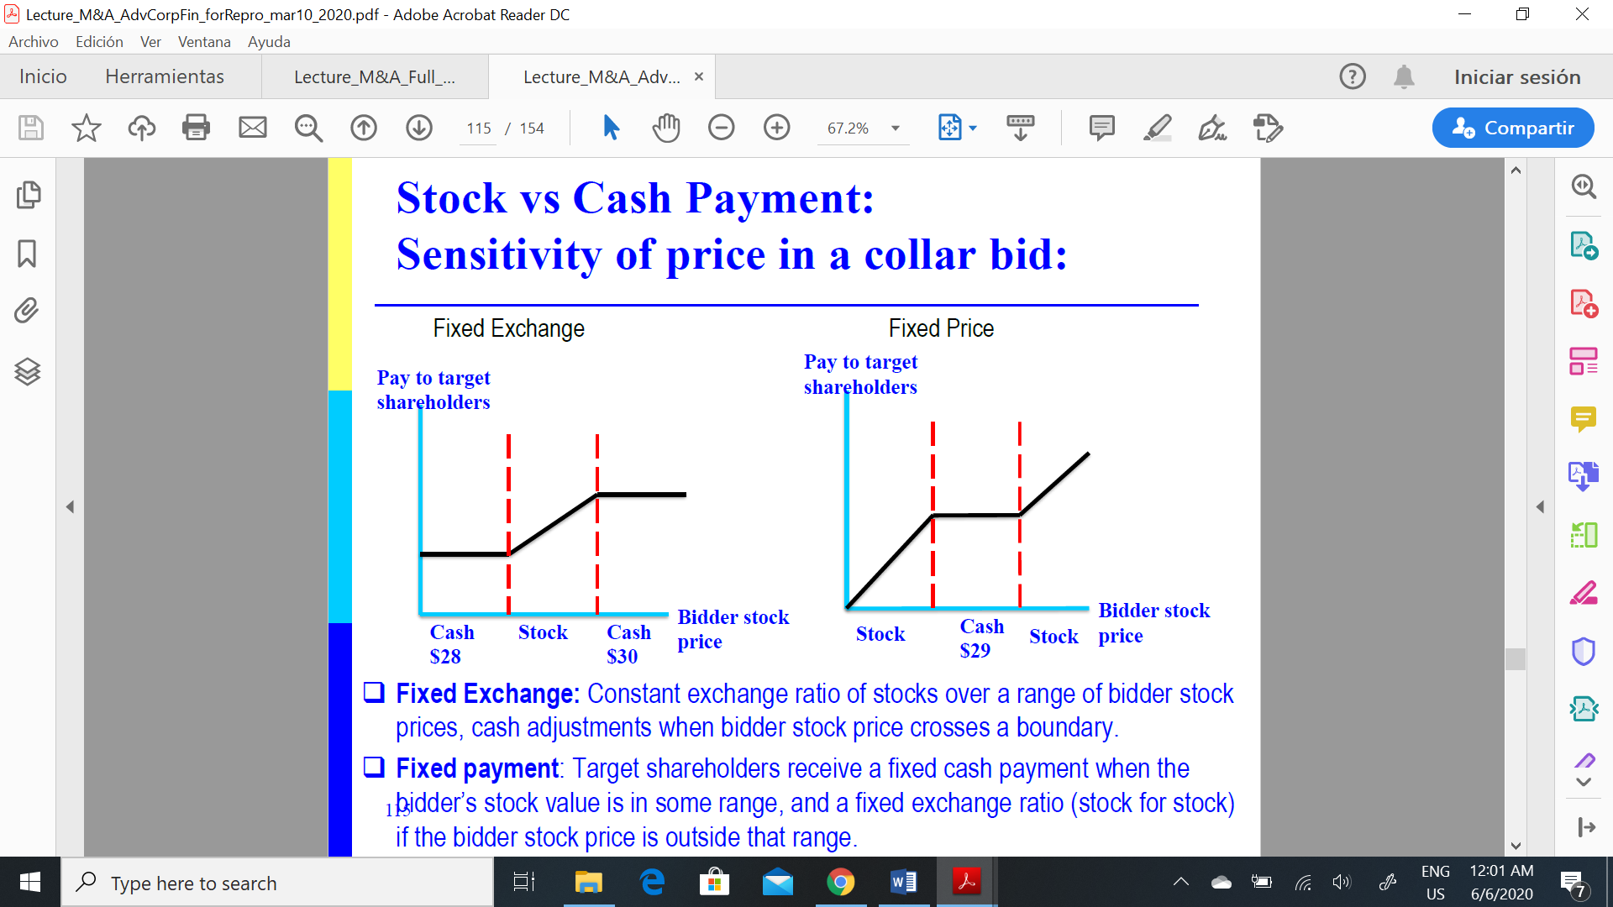

- When paying with stock: the price depends on fluctuations in the acquiring firm share price. This generates a risk for both acquirer (when the stock price rises a lot) and the target (when the stock price falls a lot)

EXAMPLE:

-First, she evaluates the value of firm B to firm A: **Value of firm B to firm A = PV(B) + PV(synergies)**

-Then she evaluates the cost of acquisition

**Cost of acquisition with cash = cash paid**

**Cost of acquisition with stock = α*PV(A+B) = α*{PV(A) + PV(B) + PV(synergies)}**

**Net gain of acquis. with cash = PV(B) + PV(synergies) -cash paid**

**Net gain of acquis. with stock = PV(B) + PV(synergies) -α*PV(A+B)**

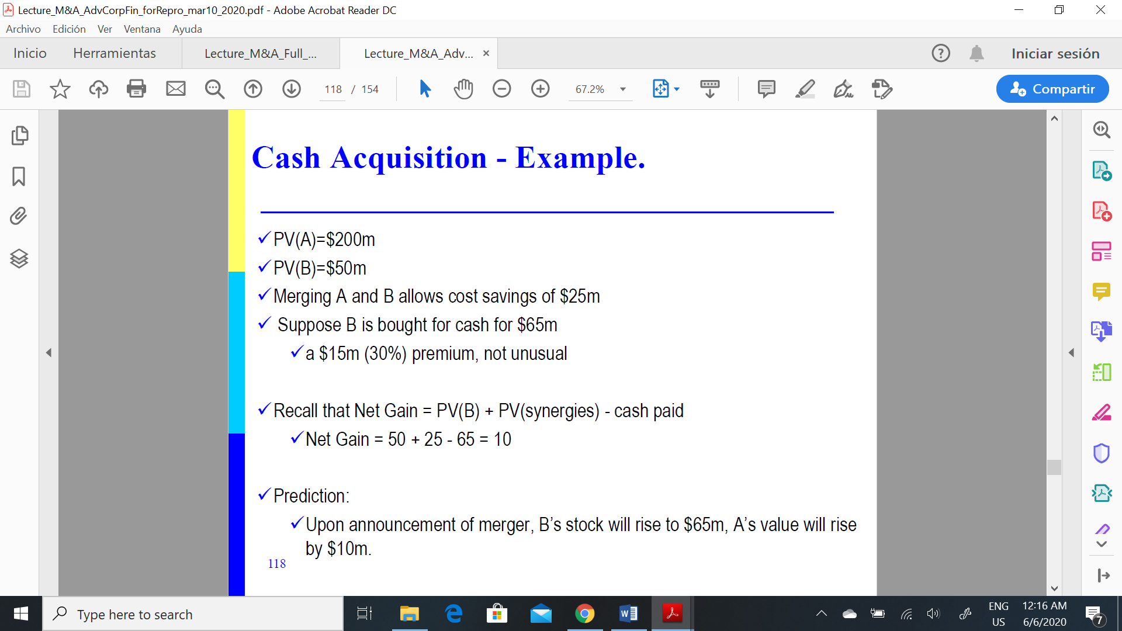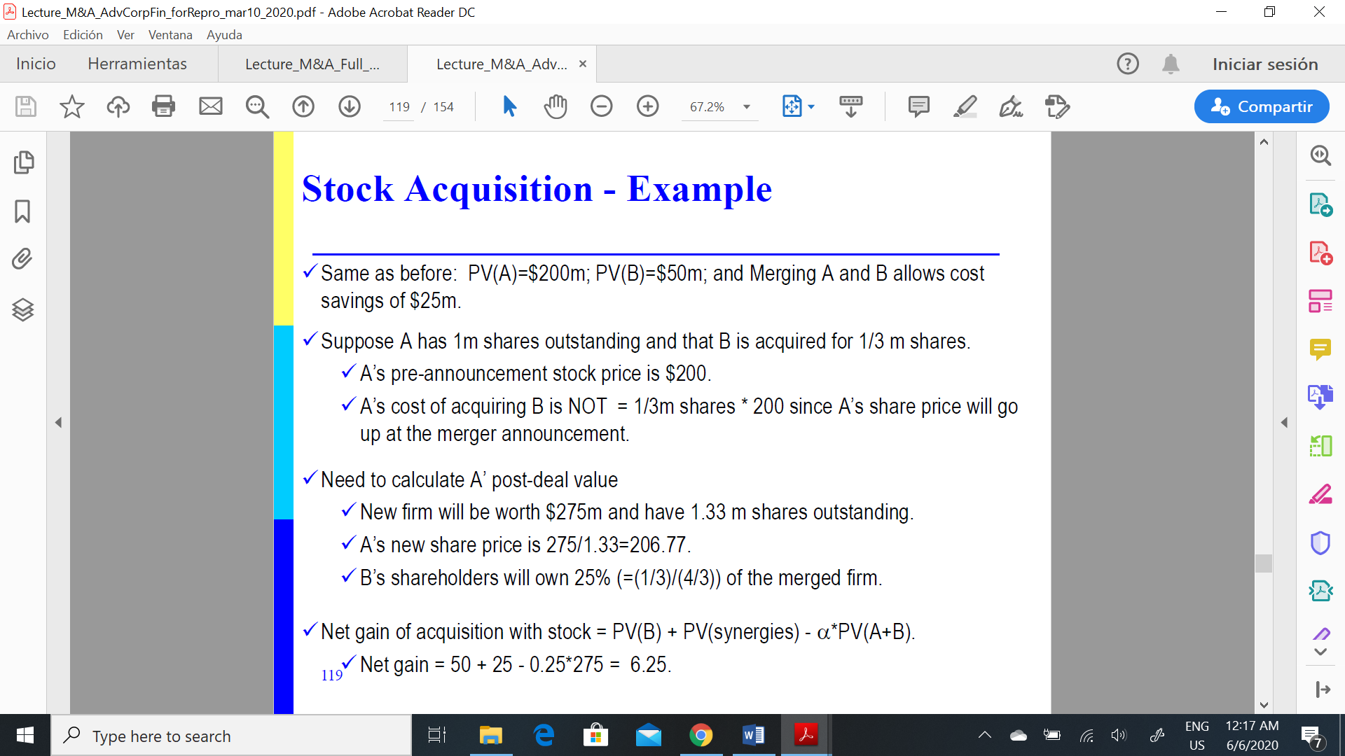

**Valuation guidelines:**

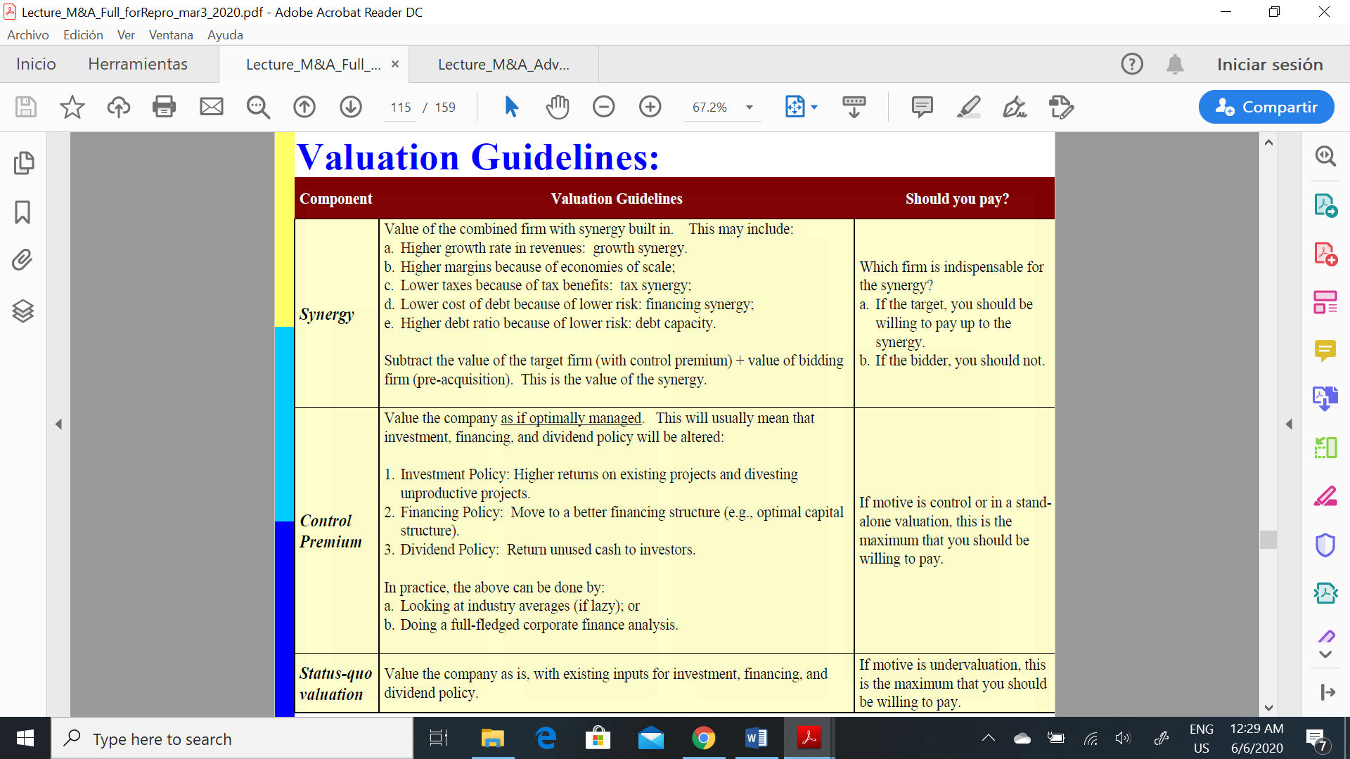

**1. Stand-alone valuation:**

- valuation based on the base-line cash flows, not incorporating any synergies or benefits the buyer may bring.

- Advantages of conducting a stand-alone valuation: floor on the negotiation process, Is the target under-or overvalued by the market 🡪 calibrate the assumptions that investors apply for the valuation.

- discount the CF with the WACC of the target

**2. Value of the control premium:**

- Value of the company when optimally managed: Changes can be on: Financial structure, Investment policy, Dividend Policy

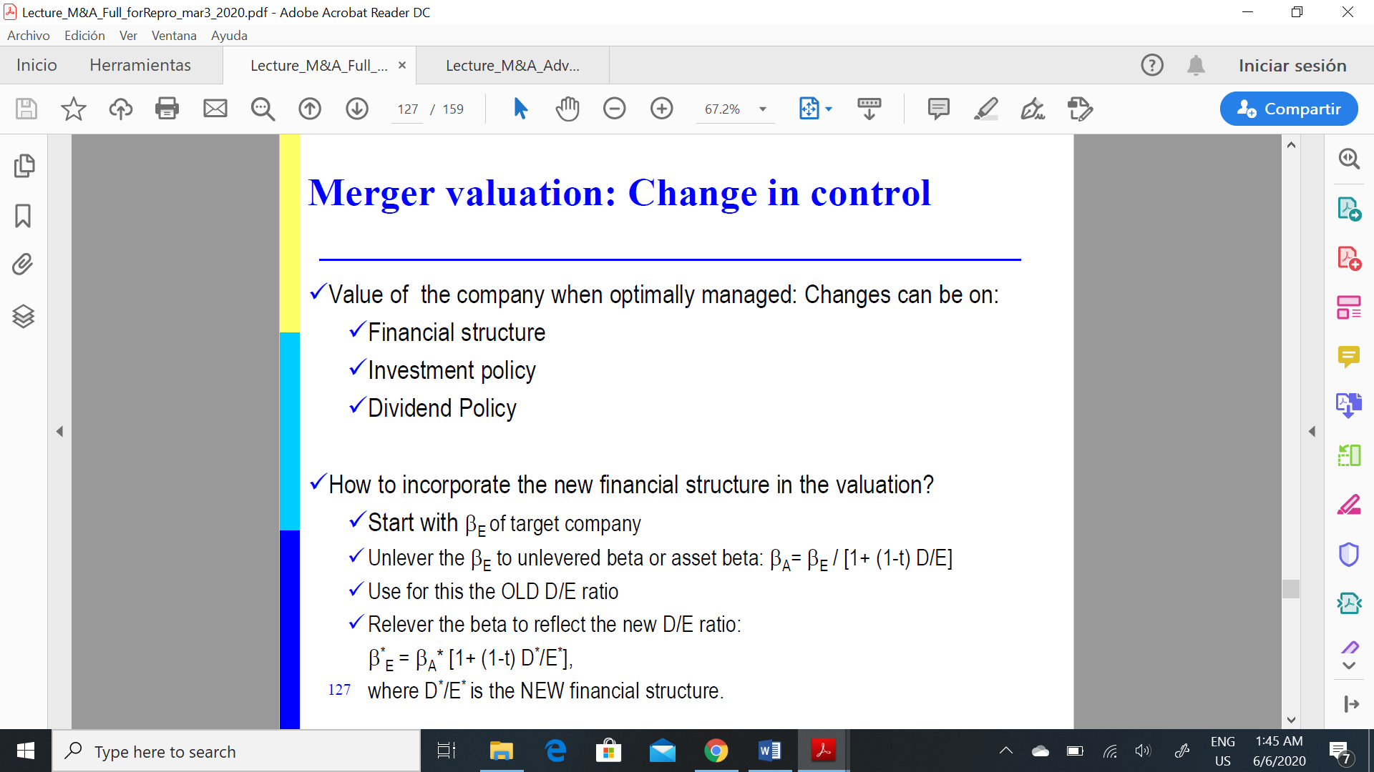

**3. Value of the synergies:**

-Synergies increase the value of the combines firm, this can be due to:

Higher cash flows (combined cash flows / merger cash flows) due to:

Growth synergy: Higher growth rate in revenues.

Economies of scale: Higher profit margins.

Tax synergy: Lower taxes because of tax benefits.

Financing synergy: Lower cost of debt because of lower risk.

Debt capacity: Higher debt ratio because of lower risk.

- Consider two scenarios:

1. Target and acquirer operate in same industry:

If they operate in the same industry 🡪 same business risk 🡪 βA is the same for acquirer and target.

Adjust the beta for the NEW financial structure and calculate the WACC on that basis (see up)

2. Target and acquirer operate in different industry:

Business risk for acquirer and target is different. Thus, estimate the business risk of the combined firm going forward.

Use the weighted average of the asset betas of the two divisions:

